**Global Patient Health and Wellness Registry**

**Dr. Christina Rahm**

**2023**

**Abstract**

**Background:** Any database that stores clinical information as a byproduct of patient care can be called a "registry." Still, the term's confusing usage makes it difficult to access data and investigate particular registries. Global patient health and wellness registries are centralized databases that gather and preserve health-related information on patients with certain medical disorders, diseases, or risk factors. Many countries, especially those in the third world areas, are challenged by the lack of an integrated healthcare registry. As a result, monitoring and analysis of disease and healthcare outcomes are undermined. There is a shortage of reliable, routinely collected data and health infrastructure in locations with limited resource access.

**Purpose:** The study aims to evaluate the effectiveness and usefulness of the new global registry created by the combination of InCytes and Benchmarc platforms by RegenMed. The assessment will focus on how the registry can benefit global leaders in healthcare. It will inform their decision-making on policies and best practices for promoting public health. The study aims to contribute to advancing global health and wellness by providing insights into the potential benefits of the new registry to help improve the health outcomes of populations worldwide.

**Methodology:** This qualitative study reviewed the literature on healthcare registries and the use of technology in healthcare data management. Literature was created from credible databases such as PubMed, ScienceDirect, Cochrane Library, EMBASE, and Google Scholar. The keywords “InCytes,” “Benchmark,” “registry,” and “global health” were used. Thematic analysis was used to evaluate the literature and the findings reported in a narrative format. The findings also explain how healthcare stakeholders may use Benchmarc and InCytes.

**Results:** The paper explains how Benchmarc works between clients and providers. This tool is an interactive website that serves as a patient portal that enables patients to watch their progress over time, take surveys to report their outcomes, and learn more about their disease. It gives patients and doctors a cause to sign up and incentivizes them to answer questionnaires as they improve. The paper then explains inCytes, as a platform that analyzes and visualizes the data once gathered and sorted. This involves seeing patterns, trends, and correlations in the data that can aid academics and medical practitioners in comprehending the health and wellness of patients. Moreover, InCytes offers resources for building interactive reports and dashboards that may be used to communicate insights to other stakeholders. The paper gives the steps for accessing and using the services provided by InCytes.

Further, the themes from the literature review are explained in detail. These include: “the current landscape of healthcare technology,” “the use of real-world data (RWD) and real-world evidence (RWE) in assessing the efficacy of medications,” “the use of registries in enhancing care coordination and patient outcomes,” and “issues of data safety regarding registries.” The features of Circles, a registry created by combining services of Benchmarc and InCytes, are further explained in this paper. These include reduced burden, patient and education compliance, interprofessional collaboration, report generation, driving influence, and the associated financial benefits. These features allow the platform to enhance care delivery, improve interprofessional collaboration, and improve disease management. The article further outlines how RWE can be used effectively. Lastly, the benefits of Circles in clinical research and among healthcare stakeholders, a major objective of the paper, are highlighted.

**Discussion:** InCytes and Benchmarc are digital platforms with many risks and benefits. A global health registry's creation and use is a challenging project requiring extensive time, knowledge, and cooperation from several parties. Some of the challenges that require attention include issues of data quality and standardization, data security and privacy, data ownership and use, informed consent, sustainability and financing, governance and oversight, integration and interoperability, cultural diversity and linguistics, technological challenges, political challenges, as well as stakeholder engagement. A lack of field study or systematic literature review weakened the study. It relied on the major themes across the selected articles, closely related to the topic. However, the use of credible resources makes the study more reliable. The articles used are from different backgrounds worldwide, making the themes more generalizable. The study also used real illustrations showing how the new global registry works. Future studies should focus on testing the registry at a global level.

**Conclusion:** This study concludes that health registries are valuable for gathering and analyzing information on certain patient populations or disorders. Registries can offer information on a disease's natural history, treatments' efficacy, and patterns that might enhance clinical decision making. The Circles platform, created by RegenMed, gathers information on health and wellbeing from various sources, such as wearables and electronic health records, to track patient outcomes and spot trends that might call for medical attention. The Global Health and Wellbeing Registry was built on the platform, and businesses like InCytes and Benchmarc teamed up with RegenMed to construct registries for chronic pain and uncommon diseases. The improvement of patient outcomes and the direction of clinical decision-making depends on healthcare registries.

*Keywords*: InCytes, Benchmark, registry, global health.

**Table of Contents**

**Abstract**...................................................................................................................................... 2 **1.0. Introduction**......................................................................................................................... 8 **1.1. Background** ........................................................................................................................ 8 **1.2. Problem Statement**........................................................................................................... 13 **1.3. Purpose Statement** ........................................................................................................... 15 **1.4. Research Questions**.......................................................................................................... 16 **1.5. Definition of Key Terms**.................................................................................................. 17 **1.6. The New Registry**............................................................................................................. 18 **2.0. Literature Review** .............................................................................................................. 20 **3.0. Methodology** ...................................................................................................................... 37 **3.1. Search Strategy and Study Selection**.............................................................................. 37 **3.2. Analytical Methods and Reporting of the Findings**................................................... 38 **4.0. Results**................................................................................................................................. 38 **4.1. About the Global Health and Wellness Registry** .......................................................... 38 **4.1.1. Benchmarc Platform**................................................................................................. 38 **4.1.2. InCytes**....................................................................................................................... 41 **Selecting Circle Role(s)**................................................................................................... 41 **Adding/Removing Team Members** ............................................................................... 42 **Registration** ..................................................................................................................... 43 **Summarized steps** .............................................................................................................. 43 **How to Accept an Invitation to a Circle**........................................................................ 44 **Health Care Provider Sign Up**....................................................................................... 45 **Healthcare Provider Registration** .................................................................................... 46 **How to Create and Test a Test Case** ................................................................................ 47 **How to Delete Test Case** ................................................................................................... 48 **How to Review Your Protocol** ......................................................................................... 49 **How to Register a New Patient** ...................................................................................... 50 **Creating a New Case**......................................................................................................... 53 **Data Entry** ....................................................................................................................... 57

**Report Building**........................................................................................................... 59 **Renaming and Removing Reports**............................................................................... 61 **Locating a Circle to Build Data** ................................................................................... 62 **Cohort Building**............................................................................................................ 63 **Adding a Cohort**........................................................................................................... 64 **Removing a Cohort**...................................................................................................... 65 **Editing a Cohort**............................................................................................................ 66 **Renaming a Cohort**....................................................................................................... 68 **Reading Legend**............................................................................................................. 69 **How to Export a Report** ............................................................................................... 70 **How to Read the Exported Report**.............................................................................. 71 **Circle Administrators**.................................................................................................. 72 **Downloading Full Raw Report**.................................................................................... 73

**4.2. Themes from Literature** ............................................................................................... 74 **The Current Landscape of Healthcare Technology** ...................................................... 74 **The Use of RWD and RWE in Assessing the Efficacy of Medications** ........................ 76 **The Use of Registries in Enhancing Care Coordination and Patient Outcomes**......... 77 **Issues of Data Safety Regarding Registries**.................................................................... 80

**4.3. Important Features of Circles (Global Health and Wellness Registry)**.................... 82 **1. Reduced Burden**.......................................................................................................... 83 **2. Patient Education and Compliance**........................................................................... 83 **3. Interprofessional Collaboration** ................................................................................ 83 **4. Report Generation** ...................................................................................................... 84 **5. Driving Influence** ........................................................................................................ 84 **6. Financial Benefits**.......................................................................................................... 85

**4.4. Effective use of Real-World Evidence**.......................................................................... 85 **4.5. Importance of inCytes and Benchmarc to Clinical Research**................................... 86 **4.6. Benefits of the Registry to Global Healthcare Stakeholders**..................................... 90

**5.0. Discussion** ........................................................................................................................ 95

**5.1. Challenges and Solutions in the Development, Adoption, and Use of a Global Health Registry** ................................................................................................................................ 96

**5.2. Strengths and Weaknesses**.......................................................................................... 100 **5.3. Ethical Considerations** ................................................................................................ 103

**6.0. Conclusion** .................................................................................................................... 106 **References**............................................................................................................................... 109 **Appendix**................................................................................................................................. 118

**1.0. Introduction**

**1.1. Background**

Any database that stores clinical information as a byproduct of patient care can be called a "registry." Still, the term's confusing usage makes it difficult to access data and investigate particular registries. Operational Domain registries provide information and direction for clinical care. A subset of operational registries integrated into the electronic health record (EHR) is called actionable registries (Berkovich & Sitapati, 2020; Ehrenstein et al., 2019). More functionality is supported by this architecture, which also improves the effectiveness of treatments. Locally authorized interpretations of the standards of care are used to create clinical protocols to develop clinical decision support systems based on registry inclusion. The actionable EHR or a data warehouse with a data storage architecture that makes quality reporting easy can be used to measure quality (Berkovich & Sitapati, 2020). The value improvement cycles are directed toward the quality reporting performance goals by the data from the quality measurement process. Observational data are gathered and compiled by subject or condition by research registries. A source of practice-based evidence is data gathered for quality measurement in the operational domain. However, observational data cannot be used for medical research without the institutional review board's consent, which is required for all studies involving human beings (Berkovich & Sitapati, 2020). Figure 23 in the Appendix section shows how these registries work or are designed. Global patient health and wellness registries are centralized databases that gather and preserve health-related information on patients with certain medical disorders, diseases, or risk factors. These patients may have been diagnosed with one or more conditions (Gliklich et al., 2018). These registries are established to improve patient care by tracking patient outcomes, monitoring how well therapies work, and analyzing the effects of various healthcare interventions.

The primary objective of global patient health and wellness registries is to compile information on people from various parts of the world who have been diagnosed with a particular medical condition. These registries allow medical professionals and researchers to gain new insights into managing these conditions, better understand the natural history of these diseases, and evaluate the efficacy of treatments in a setting more representative of everyday life (Gliklich et al., 2018). These registries provide a full view of the patient experience and assist in identifying opportunities for improvement in patient care by collecting a wide range of data points, including patient demographics, medical history, clinical outcomes, and quality of life data.

One of the primary advantages of global patient health and wellness registries is that they can assist in identifying patterns and trends in patient populations that may not be obvious from smaller, more localized studies. This is one of the key advantages of global patient health and wellness registries (Gliklich et al., 2018). Because of this, medical personnel can personalize their treatment to the specific requirements of each patient, which can lead to more efficient treatments and improved patient health results. In addition, these registries serve as a significant resource for researchers hoping to identify new targets for developing new drugs and for regulatory bodies who want to evaluate the safety and effectiveness of novel treatments.

In addition, global patient health and wellness registries have the potential to significantly contribute to reducing health inequalities and increasing access to care, particularly for patients living in communities that are not adequately served (Gliklich et al., 2018). These registries can assist in detecting gaps in care and indicate places where greater resources are needed to enhance health outcomes by collecting data from various patient populations.

Global patient health and wellness registries are crucial for advancing medical research, improving patient care, and promoting global health. They provide a wealth of information on patient outcomes and help identify areas for improvement in healthcare interventions, making them valuable resources for healthcare professionals, researchers, and policymakers alike (Gliklich et al., 2018). They provide this information and help identify areas for improvement in healthcare interventions.

"Digital health" is the technology that accepts and transmits electronic health data. This data can be utilized, either directly or indirectly, to improve or monitor health and coordinate the delivery of healthcare services. Mobile health (mHealth), wearable devices, health information technology (HIT), telemedicine, telehealth, and personalized medicine are some examples of the types of technologies that fall under digital health (Gliklich et al., 2018). Digital health also includes many other technologies that can be used in health care. Because there is no universally accepted definition for the concept, many different names, including mHealth, eHealth, social media, and the IoT (Internet of Things) as it relates to medicine, are frequently used interchangeably. This article will collectively refer to mHealth, eHealth, social media, and IoT as “digital health.”

Significant progress has been made in cost-effective, real-time technologies that can analyze disease, social interactions, movement, behavior, images, hormones, environmental toxins, and other physiological variables. These technologies have made these assessments more accurate (Gliklich et al., 2018). These advancements result from a reduction in the space and power requirements of modern technologies and an increase in the computational sophistication of the devices. Diagnostics, interventions, public health, and clinical research all stand to benefit from the potential advancements brought about by these technologies. Even though there has been a rise in the amount of research published utilizing social media, the most compelling use cases are not yet entirely elucidated, and regulations are still being formed. The influence of social media on health care has grown dramatically (Gliklich et al., 2018). Despite the progress made in digital health, there is still a lack of consensus around how the various components, devices, and technology actually function. The article by Choi et al. (2007) showcased using a global public health studies registry in creating, managing, and transferring knowledge. The registry creates a knowledge-based system for training public health practitioners. It is also useful in determining funding and policymaking. A Global Patient Health and Wellness Registry (GPHWR) would work similarly but deals with the various medical conditions that affect populations worldwide.

Clinical care management programs for chronic conditions are commonly challenged by the limited capacity to monitor patient cohorts and ensure they are periodically evaluated. This is despite the existence of underlying health problems. The monitoring would help evaluate the effectiveness of the interventions used. The utilization of registries in this domain assists in determining the patient groups at a higher risk of developing multiple adverse results and offers the care providers a chance to make the interventions more direct and efficient. Actionable registries need high accuracy to support clinical decisions because it significantly impacts resources, humans, patients, and healthcare payers.

Accountable care organizations (ACOs), affiliates, managed care plans, and quality initiatives are all connected to groupings of both active and deceased patients in patient status and coverage registries. The quality and efficiency registries monitor quality and effectiveness in ambulatory care, such as wellness exams, chronic care management, medication management, and outpatient treatments, for the actively enrolled populations (Berkovich & Sitapati, 2020). These services may be delivered in the care environment of ambulatory primary care or specialty clinics or for patients in post-acute care, such as a skilled nursing facility. Utilization and episodes keep track of the important occurrences that lead to ER visits or inpatient admissions. The longitudinal study of care is made possible by tracking these occurrences over time and connecting appropriate care in episodes (such as a pregnancy or heart attack). When operational registries are developed inside the EHR, they facilitate common disease state definitions and make retrieving curated data from the medical record easier. The integrated design, which is most significant, makes it easier to take action based on registry inclusion, exclusion, or metric value. Even though the examples concentrate on a registry architecture that is a part of the EHR, a different design may create registries in a system layer separate from the EHR. The latter strategy may be more tempting for affiliate groups whose members utilize various EHR systems.

Rare illnesses are among the conditions that threaten public health. The International Society for Neonatal Screening indicates that rare illnesses affect between 263 to 446 million people across the globe (ISNS, 2020). The findings were obtained by analyzing publicly available epidemiological evidence from the Orphanet database. According to the European definition, the results show that 67.6% of the common rare illnesses are uncommon, excluding rare malignancies, infectious disorders, and poisonings.

The evaluation of this information yields an estimate of the incidence of rare diseases among the world population at any given time of between 3.5 to 5.9% (ISNS, 2020). The authors emphasize the paper's political ramifications. Miravitlles et al. (2019) support the view that rare diseases affect many individuals and are a top concern for global health in the rare disease community's present discourse. The estimates will be improved by registry research in the future and the incorporation of ORPHA codes for rare disease codification in healthcare systems (ISNS, 2020). The results back up the community for rare diseases' years-long efforts to promote the prioritization of rare illnesses as a health issue that impacts millions of individuals worldwide, not just a select few (Boulanger et al., 2020). The importance of the global population with rare diseases is undeniable. This group of people, who up until now have been health orphans, has a critical mass and urgent need for healthcare, access to cutting-edge treatments, and a social framework that promotes their right to the best possible quality of life.

**1.2. Problem Statement**

Many countries, especially those in the third world areas, are challenged by the lack of an integrated healthcare registry. As a result, monitoring and analysis of disease and healthcare outcomes are undermined. In locations with limited access to resources, there is a dearth of reliable, routinely collected data and health infrastructure (Deen et al., 2014). A significant number of births and deaths take place in private settings and are never officially recorded. Many sick patients either do not seek medical treatment or cannot do so. Several treatment centers struggle with insufficient staffing levels and have restricted capacities for conducting laboratory tests to validate the diagnosis. These characteristics present considerable obstacles when attempting to record accurate statistics regarding morbidity and mortality. As a result, a significant portion of the public health research conducted in these contexts focuses on health burden assessments to generate the data most urgently required for public health delivery.

Also, the populace of developing countries should be regarded as susceptible since they have limited economic and political power. This means that they should be considered vulnerable (Azevedo, 2017). They must be included in health-related surveys from which they could benefit (Deen et al., 2014). The majority of the world's sick population lives in underdeveloped countries, which have access to a minuscule portion of the total funds allocated for healthcare worldwide. Epidemiological data are necessary to distribute these limited resources efficiently and to form decisions regarding the strategies that will be implemented (Deen et al., 2014). Research on public health in developing nations emphasizes the hunt for cost-effective control and preventive interventions that can benefit large community segments. This contrasts with the research that focuses on expensive procedures for individual patients.

According to the World Health Organization (WHO) (2016), integrated care is a viable solution to the increasing demand for enhanced patient experience and the health outcomes of patients requiring long-term care and having several chronic conditions. Using registries in healthcare would advance clinical research and ensure that healthcare services are well integrated (Chorostowska-Wynimko et al., 2019). The International Consortium for Health Outcomes Measurement (ICHOM) creates minimal outcome sets for each medical condition using global registries and industry best practices. In addition to bringing together and spreading best practices in outcome data collecting, verification, and reporting, it brings together clinical leaders worldwide to produce standard outcome sets. Healthcare providers worldwide should systematically evaluate outcomes by condition to permit universal comparison and spur quick improvement, like railways converging on standard track lengths and the telecommunications sector on standards to allow data sharing. Soetikno (2017) indicates that the use of registries enhances systematic reviews. Despite the efforts by ICHOM and other national-level agencies in uniting patient and clinical information databases through registries, there remains a huge gap in healthcare. These gaps can only be solved by introducing a global registry that collects, analyzes, and reports data in real-time. The new registry would lead to better procedures in decision-making, policy making, and policy reforms and enhance patient outcomes globally.

In addition, there exists an information gap in healthcare, especially the one witnessed during the COVID-19 pandemic. There is no scarcity of digital knowledge, which disseminates quickly, especially through social media platforms, amid global health emergencies (Xie et al., 2020). Such information might fill in gaps by providing knowledge that authorized institutions may not be able to give; as a result, the general public and health experts would benefit from this information. Yet, there is also the potential for false information and deception propagation. It is crucial to automatically recognize and label important and accurate text and images shared through social media (Xie et al., 2020). This is a topic that the expanding corpus of research on artificial intelligence and machine learning technologies could bring to light. With the use of a global registry, stakeholders in healthcare will be better equipped with the knowledge necessary to respond appropriately to emerging health threats on a global scale (Lübbeke et al., 2019).

**1.3. Purpose Statement**

The purpose of this study is to review the Global Health and Wellness Registry created through a combination of RegenMed's inCytes and Benchmarc platforms by the International Science Nutrition Society (ISNS). This institution combines these platforms in its clinical studies on disease. The study aims to evaluate the effectiveness and usefulness of the new global registry created by the combination of these two platforms. The assessment will focus on how the registry can benefit global leaders in healthcare. It will inform their decision-making on policies and best practices for promoting public health. The purpose of the study can be broken down into the following objectives: (1) Review the Global Health and Wellness Registry created by inCytes and RegenMed's Benchmarc platforms, (2) Evaluate the effectiveness and usefulness of the registry, (3) Identify the benefits of the new global registry for global healthcare leaders, and (4) Assess how the registry can inform decision-making on policies and best practices for promoting public health. By achieving these objectives, the study aims to contribute to advancing global health and wellness by providing insights into the potential benefits of the new registry. This could ultimately help improve the health outcomes of populations worldwide.

**1.4. Research Questions**

The ISNS uses the inCytes and Benchmarc platforms to extract longitudinal data. inCytes is a data analysis and visualization platform designed to help researchers and analysts extract insights from large, complex datasets. Benchmarc is a data management platform that helps organizations organize and analyze data from clinical trials and other studies. The use of these platforms by the ISNS suggests that the organization is likely involved in research related to nutrition and health and is using data analysis and management tools to extract meaningful insights from longitudinal studies. This qualitative research study will be based on the following questions.

1. How can the ISNS leverage the combination of inCytes and Benchmarc to create a Global Health and Wellness Registry?

2. What possible outcomes will assist Global healthcare leaders in making more collaborative decisions on the best pathways to wellness, prevention, and overall healthcare per a diagnosis?

**1.5. Definition of Key Terms**

The Global Health and Wellness Registry is an integrated health registry that combines the services of inCytes and Benchmarc. This registry would allow researchers, patients, and other users to enter, access, and disseminate data in real-time. The Benchmarc platform would gather and store the data in a centralized database once the pertinent data points have been recognized. Large volumes of patient data from many sources can be managed and organized using Benchmarc, which offers a safe and scalable solution. The platform is a patient portal that provides patients with useful information about their health, allows them to monitor their progress, and allows them to report their results. The portal's interactive and user-friendly design allows patients to access vital health information and treatment information.

Benchmarc's survey tool, which enables patients to report their outcomes over time, is one of its key features. With the help of this feature, patients can give doctors insightful feedback about how well their treatments are working while doctors can better track patients' progress. The surveys are thorough and simple to complete, giving patients a clear picture of their healing process. Benchmarc offers patients educational materials about their medical condition and the survey tool. These tools are created to meet each patient's needs and are intended to aid in their understanding of their condition, available treatments, and the healing process. The way this information is presented makes it simple for patients to understand and apply.

Benchmarc offers patients a sense of ownership and controls over their recovery, which is one of its main advantages. Benchmarc empowers patients to actively participate in their recovery by giving them access to information about their condition and treatment and a platform to report their results. This can be especially helpful for patients who might feel alone or overburdened by their illness (Damen et al., 2020). Benchmarc is a cutting-edge and useful tool for both patients and medical professionals. Benchmarc helps patients take an active role in their recovery process by giving them access to useful information and a platform to report their outcomes. Benchmarc also gives clinicians the tools to track patient progress more effectively.

The inCytes platform analyzes and visualizes the data once gathered and sorted. This involves seeing patterns, trends, and correlations in the data that can aid academics and medical practitioners in comprehending the health and wellness of patients. Moreover, InCytes offers resources for building interactive reports and dashboards that may be used to communicate insights to other stakeholders. The global registry made by combining inCytes and Benchmarc would help advance global health, a field of study, research, and practice emphasizing global and multidisciplinary health concerns, determinants, and solutions while encouraging interdisciplinary collaboration. Its goals are to improve health and achieve equity in health for all people worldwide.

**1.6. The New Registry**

InCytes and Benchmarc are both data management and analysis platforms that can be used to create and maintain a Global Patient Health and Wellness Registry. Finding the essential information on patient health and wellness would be the first stage in creating a registry. Demographic details, medical history, lifestyle factors, and any other information pertinent to the particular health conditions being tracked may be included in this. Benchmarc and inCytes work well together to create a Global Patient Health and Wellness Registry that can help advance the knowledge of patient health and wellness and guide the development of novel therapies and interventions. To gather, preserve, and analyze patient data from clinical trials and other studies, RegenMed created the Benchmarc platform. Using the platform, researchers and healthcare practitioners often manage and analyze large volumes of patient data. The site also offers functions created especially for patients participating in research or clinical trials. A few examples of these patient-facing features are a user-friendly interface that makes it simple for patients to enter and maintain their own data and capabilities for following their development over time. The platform may also give alerts or messages to patients, reminding them of appointments or follow-up chores. RegenMed's Benchmarc platform may help increase patient engagement and retention in clinical trials or other research by giving patients a tailored, convenient, modern user experience. This results in more accurate and comprehensive data and a greater understanding of the health and welfare of the patient.

As highlighted above, a consolidated database of patient data can be built using InCytes and Benchmarc that incorporates clinical data gathered during the patient's initial evaluation and follow-up visits or interactions with healthcare professionals. This information can be used to monitor a patient's development over time and assess how well they are accomplishing particular objectives their healthcare professional sets. By comparing a patient's current blood pressure readings to their initial clinical data, a doctor can use InCytes and Benchmarc to track their progress toward a goal, like lowering their blood pressure by a certain level over a certain amount of time. Using InCytes and Benchmarc enables a more thorough and integrated picture of the patient's health data, which can aid healthcare providers in making better choices regarding their treatment. Using a patient portal, patients can also gain access to their data, increasing patient engagement and enabling them to play a more active part in managing their health. Overall, InCytes and Benchmarc offer a strong platform for monitoring patient development about goals set by clinicians, which can help to improve patient outcomes and lead to better healthcare decision-making.

**2.0. Literature Review**

The study by Marrie et al. (2021) explored the use of the North American Research Committee on Multiple Sclerosis (NARCOMS) registries in aiding the treatment of multiple sclerosis (MS). The natural and treated history of MS can be elucidated with the help of observational studies and registries and the factors linked to outcomes. These include disability, and health-related quality of life can be identified (Marrie et al., 2021). Both of these can play an important role in the research process. One of a relatively small number of patient-driven multiple sclerosis registries, the NARCOMS Registry is one of the many registries worldwide that focus on people with multiple sclerosis (MS).

Marrie et al. (2021) indicate that information on individuals is typically compiled and stored in registries. One way to categorize them is according to whether they are concerned with 1) exposure to a specific illness or condition, such as multiple sclerosis; 2) exposure to a health care product, like a device or drug; or 3) exposure to a certain health care service (Marrie et al., 2021). Although most registries collect information before or after a particular intervention, some do collect data after the intervention. Observational studies, also known as noninterventional studies, are the method of choice for registries when it comes to data collection. Registries have several advantages over real-world data sources, such as managerial databases or EMRs. These advantages include the possibility of gathering long-term outcomes, uniform data collection according to standard data definitions, and more extensive clinical data than can be obtained from administrative data (health claims data). Also, they might record the outcomes as reported by the patients (Marrie et al., 2021; Ruseckaite et al., 2022). Conversely, registries have issues associated with sustainability, the possibility of selection bias, and the requirement to track and preserve data quality.

Marrie et al. (2021) note that its purpose should be specified in detail to guarantee that the information gathered from a register will be suitable for its intended use. Patient registries can be utilized for a variety of purposes, including but not limited to the following: to gain an understanding of the natural and treated history of a disease as well as prognostic factors; to gain an understanding of the treatment of a disease; to investigate outcomes like socialization, employment, and inequalities in care; to measure the quality of care provided; or to monitor treatment safety and harm (Marrie et al., 2021). Therefore, registries play an important role in bringing all the aspects of patient care together for easier review.

A study by Lauer and D'Agostino Sr (2013) noted the use of disruptive technologies in randomized studies. The authors discuss how the use of registries has transformed research. They note that using randomized trials, which allow clinical researchers to assess the efficacy of novel (or established) medicines while considering the effects of unquantified confounders and indication-specific selection bias, is one of the most powerful techniques available, according to the authors. Large-scale megatrials, in particular, have revolutionized medicine. Randomized trials have made it possible to stop using lidocaine and nitrates to treat acute myocardial infarction. Beta-blockers, statins, and angiotensin-converting enzyme inhibitors are frequently prescribed during long-term follow-ups in place of anticoagulants, rapid revascularization, and antiplatelet medicines (Lauer & D'Agostino Sr, 2013). According to the authors, the reputation of randomized trials has also been impacted due to legitimate worries about their excessive complexity, cost, and time to recruit study participants, as well as their lack of representativeness. What use are clinical trials if their findings do not apply to real-world patients and if, due to their high cost, they can only be utilized to provide partial answers to the most pressing clinical questions?

As Lauer and D'Agostino Sr (2013) note, looking for answers in observational registries is one option. Several professional societies, government organizations, corporate businesses, and independent researchers have established high-quality registries that gather standardized data from patients seen in a range of settings. For instance, in the field of cardiovascular medicine, both domestic and international registries have amassed enormous amounts of data from individuals suffering from acute coronary diseases, stable cardiovascular illness, and heart failure, as well as from patients with uncommon diseases like hypertrophic cardiomyopathy and patients who were referred for surgery, percutaneous surgery, and device implantation (Lauer & D'Agostino Sr, 2013). Researchers and public health authorities use registries to characterize practice trends and patterns, spot outliers, and flag warning signs. They frequently employ registries to evaluate comparative effectiveness, but they must acknowledge that results obtained just from observation may not be internally valid due to the lack of randomization.

The randomized registry trial is an example of a disruptive technology that modifies current norms, practices, and financial frameworks. Would it be seriously taken into account to resolve the acknowledged shortcomings of the present clinical-trial design? Randomized efficacy trials, which can cost tens or hundreds of millions of dollars, are no longer financially feasible (Lauer & D'Agostino Sr, 2j 013). Registries and other potent digital channels are also available, nevertheless. With what exists today—larger data and tighter budgets—it might be conceivable to plan and carry out megatrials (Lauer & D'Agostino Sr, 2013). However, there is also a need to be cognizant of the enormous obstacles that many research groups and stakeholders must surmount to get there.

Corrigan-Curay et al. (2018) state that "real-world" experience has remained the primary resource for creating novel medical therapies for hundreds of years. Before the introduction of the contemporary randomized clinical trial, discoveries were made, such as citrus fruits healing scurvy, which was documented in the 1700s, and insulin as a cure for diabetes, which was discovered in the 1920s (Corrigan-Curay et al., 2018). These disorders had characteristics such as an accurate technique of diagnosis, a predictable clinical course, and a significant and readily apparent effect of the treatment. Real-world evidence, often known as RWE, is a method of evidence that has been gaining more traction as of late, despite the prevalence of the modern clinical trial model. Even though this shift moved medical science toward higher scientific rigor, it simultaneously reduced the use of evidence created through practice-based observations and lowered the value of such evidence. Randomization and blinding have evolved into the industry recognized gold standard for analyzing treatment effects (Corrigan-Curay et al., 2018). In clinical trials, patients with a wider range of illness severity and age, who were using a wider variety of concomitant drugs, and who had more and different comorbidities were not represented.

Modern clinical trials make it possible to draw strong causal conclusions concerning the efficacy of treatments. As a result, they lead to substantial evidence of effectiveness that is required for regulatory approval (Corrigan-Curay et al., 2018). This is accomplished by controlling for key sources of bias and ensuring that study groups are appropriately matched. On the other hand, these tests come with several significant drawbacks, such as steep financial obligations, large resource needs, and frequently extended testing periods. It can be difficult for some patients to enroll in clinical trials due to stringent inclusion criteria and the intensity of trial sites in some health systems (Corrigan-Curay et al., 2018). This is especially true for patients dealing with multiple medical conditions simultaneously, particularly if their mobility or cognitive abilities are impaired. There is a possibility that the test population does not accurately represent the larger population that will ultimately use the medicine.

As a result of the increasing accessibility of digital health data—which has been spurred largely by the transition to EHRs—there has been a resurgence in interest in using RWD to improve the efficacy of research and bridge the evidentiary gap between clinical research and practice. This interest has arisen due to a renewed interest in using RWD to improve the efficacy of research and bridge the evidentiary gap (Corrigan-Curay et al., 2018). In addition, factors such as the increasing costs of traditional trials and the limitations commonly acknowledged have contributed to this resurgence of interest. RWD can be defined as data routinely collected from various sources, such as the electronic health record (EHR) and administrative data relating to the health condition of patients or the delivery of health care to those patients. RWD can also be defined as data routinely collected from various sources, such as the EHR and administrative data. As part of the 21st Century Cures Act, the US Foods and Drugs Administration (FDA) has been entrusted with designing a program that will examine the use of RWE to either support the approval of new indications for already-approved medications or to satisfy the post-approval research criteria (Corrigan-Curay et al., 2018). RWE is the clinical evidence addressing the usage and prospective advantages or dangers of a medicinal product obtained from the RWD study.

The FDA uses RWD regularly to offer information concerning the safety of drugs. It does this by inferencing claims and pharmacy data drawn from over 100 million individuals who are part of its Sentinel System (Corrigan-Curay et al., 2018). Additionally, Federal policies acknowledge that historical regulations taken from clinical settings can be used as reference groups in only one intervention group treatment study that provides significant evidence of effectiveness. This is the case, for instance, when the course of the disease can be predicted, and the drug's effect is substantial (Corrigan-Curay et al., 2018). In this study, the response rate at the threshold was compared with historical data taken from 694 patients who were considered comparable and taken from more than 2000 patient records taken from clinical studies and treatment locations in the United States and the European Union (Corrigan-Curay et al., 2018). Such measurements can be easily achieved using registries.

The FDA is currently concentrating on identifying other domains where RWD may be utilized to create efficacy evidence. The quality and appropriateness of the underlying information and the analytical procedures used to generate the evidence must be evaluated as part of this process (Corrigan-Curay et al., 2018). Nevertheless, claims data do not capture most of the clinical endpoints used to support new indications for medications that have already been approved. Thanks to the Sentinel program, the FDA has great expertise in using claims data. EHRs can give more granular clinical data, such as laboratory findings, imaging, and clinical evaluations; nevertheless, EHR data are frequently unstructured and sometimes inconsistent due to the different entry methods used by different clinicians and health systems. This should not come as a surprise, given that the data contained in EHRs are not currently created for further research.

The FDA’s Oncology Center for Excellence has entered into research in collaboration with CancerLinQ and Flatiron Health, which is creating quality real-world oncology data and the big data initiative of the American Society of Clinical Oncology. These collaborations aim to understand better how RWD can be utilized to inform regulations (Corrigan-Curay et al., 2018). Each collaboration aims to understand better how new immunotherapies might be applied in real-world settings by utilizing RWD. These and other FDA projects evaluate electronic health data's accuracy, completeness, and consistency, similar to the standards provided by Circles (Corrigan-Curay et al., 2018; RegenMed, 2023a). The results of these evaluations will ultimately guide the FDA's evaluation of the data's suitability for use in regulatory investigations.

There is a lot of controversy surrounding how to generate RWE using analytical methods most effectively. Randomization is still the most important method for providing strong support for causal inference, even though the context for tradition may lower the external validity of the results (Corrigan-Curay et al., 2018). Applying this important scientific tool to the environment in which it will be used can reduce confounding factors while simultaneously enabling data generation from populations that most reflect patients who will be prescribed the approved drug. The use of randomization within the context of clinical treatment has the potential to lead to the inclusion of a greater number of patients and to make it easier to observe patients in the clinical setting in which they often work. Randomized controlled trials have the potential to become increasingly incorporated into clinical practice. These studies can be built on the foundation of big, straightforward trials (Corrigan-Curay et al., 2018). These studies may incorporate "pragmatic" elements, which aim to simulate how an intervention might be implemented in regular clinical practice. As research is integrated into clinical settings, it is possible that new issues will arise regarding clinicians' workflow and that more training will be required to ensure effective clinical research practice.

The FDA is providing funding for the 1st randomized clinical study in Sentinel, which up to this point, has only been utilized to evaluate the drug's safety to gain insight into how RCTs can be carried out in real-world scenarios. The IMPACT-Afib trial tested an instructional approach to address the essential public health issue of underutilizing effective drugs to lower the risk of stroke following atrial fibrillation (Corrigan-Curay et al., 2018). Additionally, the results of this trial show evidence of the concept of RWE application in future clinical trials. The Food and Drug Administration acknowledges the growing desire to generate evidence of effectiveness through RWD and observational approaches. It is especially advantageous to study uncommon events using large patient databases, particularly when the rare events can be easily identified and are unique to the studied condition (Corrigan-Curay et al., 2018). Observational studies that use statistical methods specifically tailored to their needs have the potential to give data that can help inform decision-making regulations. The FDA has traditionally depended on observational controls in situations where the endpoints have been clearly outlined, and the pathophysiology of the disease may be anticipated and sufficiently understood. Certain information or missing information may arise in observational studies to determine when big data sets and statistical models are sufficient to correct for systematic bias in sample selection. This creates a specific issue with retrospective studies in which relatively poorly patients limit adjustments for confounders.

Further research is required to determine when big data sets and statistical methods are sufficient to do so (Corrigan-Curay et al., 2018). As part of this initiative, the FDA is providing funds for a study that will investigate whether observational approaches may be used to duplicate the results of around 30 clinical studies that were supposed to offer data regarding the efficacy of a treatment. The FDA will receive assistance from this study in better understanding how observational approaches might be employed to solve concerns affecting the efficacy of drugs. The work of the FDA should offer some insights into possible applications of RWE for decisions about regulation. However, these efforts are only a small part of a broader difficulty. To properly exploit RWD and RWE for the goals of public health, joint learning and collaboration between clinicians, patients, healthcare systems, drug manufacturers, and regulators is important. Further teamwork will be required to establish high-quality, interoperable data networks that can be leveraged for research and care delivery (Corrigan-Curay et al., 2018). Just as the commercial data collaborators in Sentinel see the worth in working collaboratively to enhance safety, so will these partners need to see the value in working together to create these networks. It will also be essential to use technological advances, like mobile health, to capture patient experiences. This will be necessary to make the research patient centered.

In a study similar to that of (Corrigan-Curay et al., 2018), Lasky et al. (2020) explored using RWD and RWE in pediatric care. RWE can supplement evidence that is gained from regulated clinical research. RWE can provide generalizable information at a reduced time and cost less than traditional clinical trials. This is especially important in pediatrics since there may be an insufficient evidence foundation to direct pharmaceutical use in children. However, the application of RWE in pediatrics has not been detailed. This is especially essential in pediatrics. RWD is the data periodically collected from various sources, claims and billing activities, EHRs, disease and product registries, patient-generated data, and mobile devices. These data relate to patients' health status and healthcare delivery. RWD is clinical data about the usage, possible advantages, or hazards of a medicinal product produced by RWD analysis. RWD stands for randomized, placebo-controlled trials. Both randomized clinical trials and observational studies can contribute to generating RWE.

However, the difficulties associated with traditional clinical trials increase the need to capitalize on the possibilities offered by RWE fully. Because of the efforts made to increase the number of clinical trials that include children, there has been an impact on the evidence base due to these efforts. This impact may be seen in the development of pediatric drug labeling. Lasky et al. (2020) established that a limited body of observational studies conducted in 2016 was classified as using real-world data to evaluate the medication's efficacy or safety in children on the study team. These studies were published in 2016. The research looked at studies that varied in age groups, illnesses or conditions, and procedures, and it is possible that some of those studies didn't entirely meet the criteria for RWE set by the FDA. According to the findings of the review conducted by Lasky et al. (2020), the application of RWE is not yet fully developed in pediatrics. This finding points to the possibility of further developing capabilities and more fully leveraging administrative and EHR databases to investigate the medication's effectiveness and safety in children. Lasky et al. 's (2020) systematic review appears generalizable to pediatrics. It documents that the high activity level in RWE, in particular, has had less influence on pediatrics.

The use of healthcare registries has shown success in running patient-centered medical homes. PCMHs are being developed and pushed in the United States as a paradigm for improving primary care services (WHO, 2016). These homes are designed around the needs of individual patients. The lack of access to basic care, difficulty navigating complex care systems, and rising care costs contributed to the interest in primary care medical homes (PCMH). Its principles were accepted by various purchasers, professional organizations, and consumer advocacy groups, and it was promoted by some of the country's largest primary care physician associations. In general, a patient-centered medical home (PCMH) refers to a physician-directed group practice that can give care that is easily accessible, ongoing, complete, and coordinated while also taking into account the patient's family and community. The PCMH model is an alternative individual primary care model in which individuals are assigned to personal medical homes and physicians. This model takes a holistic intervention for chronically ill patients and multiple comorbidities (WHO, 2016). As a result, the PCMH should not be seen as a location in which treatment is provided but rather as an all-encompassing model of organization that carries out the fundamental duties associated with primary care. Comprehensiveness, putting the patient first, patient-centered care, coordination, accessibility, high quality, and patient safety are the primary characteristics of a PCMH.

The PCMH model suggests that all care types, including subspecialty care, health centers (clinics and hospitals), home health organizations, and nursing homes, as well as stakeholders, including community, family, public, and private community-based services, should be integrated, either physically or virtually (WHO, 2016). This is an argument that is central to the model. It is distinguished from other models in that it provides patients with primary care physicians who are assigned to them. This ensures that patients are aware of who is responsible for their health and that providers are aware of the patients they are responsible for. By proactively coordinating individuals to the most appropriate care, PCMH is considered the gate opener to care, as opposed to managing or limiting access to treatment (WHO, 2016). Using registries enhances care appropriateness (Wilcox & McNeil, 2016). This indicates that most care is provided by multidisciplinary teams working in primary care; however, if a patient requires a specialist's services, primary care teams will pay for those services on the patient's behalf. The PCMH model implements the idea of shared responsibility for a patient's health, also made possible by a unified payment system for providers. Along with information technology and health information exchanges, patient registries are recognized as playing a unique part in the success of PCMH models (WHO, 2016). This is done to ensure that patients receive the appropriate services when and where they need them in a culturally and linguistically appropriate manner.

In a study by Franklin et al. (2020), the effectiveness of a wellness registry for cervical cancer is explored. The registry reviewed in this study contains data that covers screening in women. The authors note that an important determinant of the quality of medical care is whether or not preventive health services and screenings are appropriately matched with the patient's level of risk. Overscreening for cervical cancer in the United States causes unnecessary medical costs and distress for many women with minimal or almost no risk of the disease; as a result, this overuse of screening is an indicator of lowered healthcare quality (Franklin et al., 2020). It is difficult to change the behavior of doctors and adapt the practice to new information, but doing so is vital to reduce the overuse of screens and other preventive health services to conserve these resources and avoid interventions that are not necessary. The American Board of Internal Medicine Foundation launched the national project "Choosing Wisely" in 2012 to reduce unnecessary screening and increase the number of people getting the necessary screenings. The purpose of the new cervical cancer screening (CCS) registry explored by Franklin et al. (2020) was to reduce the number of screenings women had to undergo. This registry helped reduce the cost of care and alleviate anxiety symptoms resulting from unnecessary screening procedures.

Franklin et al. (2020) state in their discussion that they aimed to determine the current incidence of overscreening for cervical cancer. The evolution of CCS rates following the introduction of the consensus guidelines for CCS in 2012 and variations in screening rates according to patient characteristics was among the findings of interest. Between 2005 and 2008, 26.8% of women aged 18 to 20 underwent cervical cancer screening; between 2013 and 2016, that number dropped to 24.8% (Franklin et al., 2020). Despite this being a good and statistically significant decrease, 25% of this age group’s women received CCS in violation of the recommendations (Franklin et al., 2020). The frequency of overscreening ranged from 10% to more than 50% in other surveys of this age group (Franklin et al., 2020). However, even at baseline, fewer women 65 and older received CCS than in other surveys. Between 2005 and 2008 and 2013 and 2016, there was a little but statistically significant rise in the proportion of older women who received CCS. The disparity between reduced CCS prevalence outside of recommendations in Franklin et al. 's (2020) study and other studies of women over 65 may be due to several factors. One factor was the utilization of self-report in earlier studies to evaluate Pap testing, which could inflate the number of women who get screened since it relies on recall and because participants might not comprehend the phrase "Pap test." Another factor was that the project's design left out data on Pap tests performed outside the healthcare system, which could have led to underestimating Pap test rates.

In Franklin et al.’s (2020) study, there was a correlation between insurance status, Spanish ethnicity, and black race with overscreening for cervical cancer. Medicare insurance was linked to overscreening in women between 18 and 20. Early Medicare enrollment may be linked to chronic diseases that require more frequent visits to the healthcare system and more chances to be eligible for CCS (Franklin et al., 2020). Public insurance, such as Medicaid or Medicare, is linked to overscreening for cervical cancer in women 65 or older (Franklin et al., 2020). Other studies have not found an association between demographics and excess CCS or have found an association between excess CCS and demographics, such as younger age, identifying as White, having at least some college education, being married, or having an income three times more than federal poverty level (Franklin et al., 2020). Identifying patient traits linked to overscreening is at odds with the findings of these other investigations. The fact that other demographic characteristics imply health insurance status—which may vary with the highest correlation—can account for this discrepancy.

Cervical cancer overscreening was also linked to increased participation in the healthcare system, as seen by the availability of an activated personal health record. Although younger patients are expected to use the health information system's online access more frequently, discrepancies in the number of active personal health records cannot be solely attributed to the younger age distribution of the Pap test group (Franklin et al., 2020). Significantly more women in the Pap test group who were 65 or older also had active personal health records (Franklin et al., 2020). This suggests that women more involved in the healthcare system are more likely to receive CCS outside recommended guidelines. This could be because they visit the hospital more frequently, increasing their chance of being offered screening. Due to their high level of involvement with the healthcare system, these patients are very simple to contact. They may be open to hearing persuasive messaging regarding the reasons for CCS.

A specific proportion of CCS performed at or after age 65 is anticipated to be necessary due to risk factors (Franklin et al., 2020). Findings from a random chart review of 100 women who had Pap tests show that 25% of the women in this group were 65 or older and had CCS for an identified reason. 11% of the women under 21 years old received CCS due to an earlier abnormal screening test (Franklin et al., 2020).

To effectively match preventive health treatments and screening to patient need and control healthcare costs, nurse practitioners and patients must embrace and adhere to evidence-based guidelines more frequently (Franklin et al., 2020). Overscreening for cervical cancer is important for nurse practitioners and other healthcare professionals because it raises the possibility of needless tests and procedures and greater healthcare expenditures (Franklin et al., 2020). Overscreening is a quality indicator (Franklin et al., 2020). Avoiding health screening has been linked to a fear of painful exams. These discoveries have several clinical ramifications. For people 65 and older, clinical practice in the health system adheres to current recommendations more closely than for younger women (Franklin et al., 2020). With the introduction of the 2012 CCS consensus standards, there was a decrease in Pap tests among those between the ages of 18 and 20, consistent with other findings (Franklin et al., 2020). Removing CCS before age 21 will end the need for additional testing, evaluation, and treatment after abnormal tests.

Overscreening can be reduced in part by addressing provider barriers. The Choosing Wisely campaign names time restraints, worry about liability, patient requests, and problems with funding as provider hurdles. To further reduce overscreening, nurse practitioners and other clinicians can adopt quality improvement initiatives, including patient education on the benefits of delaying screening until age 21 (Franklin et al., 2020). The hurdles of time restrictions and patient requests can be addressed. Using approaches like targeted clinical decision assistance in the EMR, wall posters in exam rooms, and social media blasts to patients may reduce unnecessary exams and the ensuing healthcare costs. In this study, 10,918 women underwent Pap tests against the recommended practice (Franklin et al., 2020). The wasteful healthcare expenses for Pap tests in this study, excluding charges for office visits or other costs, are projected to be $545,900 using a $50 Pap test cost (Franklin et al., 2020).

In another study by Pollard et al. (2009), a patient registry's effectiveness in managing diabetes is explored. The researchers noted that by enhancing record-keeping and individualized care, electronic patient registries could, for instance, help lower obstacles to comprehensive care. Even the idea has been floated that a registry is necessary for diabetic management programs to succeed in enhancing diabetes outcomes. Yet, since data have proven improved service processes and clinical outcomes, the significance of computerized patient registries for managing diabetes in rural clinics is becoming recognized. Most research has been done in metropolitan settings or nations with universal health care. In these trials, the registry's introduction was done concurrently with the implementation of other interventions. Outreach to vulnerable patients by mail and phone, distributing educational materials to patients and healthcare professionals, and community-based activities were all interventions (Pollard et al., 2009). When the study was done, it was unclear if regular registry operations or other ongoing interventions had brought about advancements. In situations with limited resources, improvements in care without the cost of additional interventions are especially beneficial.

The results obtained by Pollard et al. (2009) suggested that only when the registry was used at a moderate level or higher did the results indicate that a basic electronic registry helped improve patient care and patient outcomes for diabetic individuals in Federally Qualified Health Centers (FQHCs). This study also demonstrated improvements after registry implementation in the absence of other ongoing interventions. Intentional, co-occurring treatments that call for more resource base than FQHCs typically have complicated earlier studies looking into the effects of registry use (Pollard et al., 2009). The registry usage linked to beneficial results in this study was fairly straightforward. It included enthusiastic registry upkeep, the use of progress notes generated by the registry that highlighted laboratory values and services that were either overdue or deviated from advised guidelines, registry use at the point of care, and registry generated review to monitor patients' care.

From the study's findings, it is unclear whether the reported care improvements correlated with registry use were brought about by the registry or by better documentation. However, the findings imply that improvements were driven by the registry, not just better documentation in cases where clinical outcomes improved with care methods (Pollard et al., 2009). Patients' cholesterol and LDL levels improved when FQHCs chose to use the registry at a moderate or higher level. As FQHCs decided to use the register sparingly, HbA1c levels gradually deteriorated (Pollard et al., 2009). Patients from these FQHCs also had lower baseline HbA1c levels than those with high baseline values. Therefore, registries can potentially improve the quality of care and patient outcomes.

In a study by Baumgart (2020), it is noted that the pandemic caused by COVID-19 has presented challenges to healthcare systems worldwide. Because of the unpredictability of transmission, the constraints of the physical infrastructure, supplies, and the labor force shortages in the healthcare system, it is necessary to dynamically adapt the deployment of resources to manage the rapidly changing care demands (Baumgart, 2020). Ideally, this should be done based on RWD for the entire population. In addition, the shutdown of the face-to-face care infrastructure necessitates the immediate deployment of various virtual healthcare options to prevent the collapse of health organizations. One of the largest population-based deployments of a comprehensive EMR is the Alberta Electronic Health Record Information System (Baumgart, 2020). The long-standing and stable telehealth hardware, provider compensation, training, and legislative infrastructure that Alberta possesses have made it possible for the province to shift to virtual healthcare quickly.

Virtual health services such as asynchronous safe clinical communications, real-time virtual care, and coordination between primary care physicians, specialists, and other healthcare professionals are all included in virtual health services (Baumgart, 2020). Additionally, the rapid launch of online screening and triage tools to guide testing and isolation, the online sharing of results, patients and contact tracing, electronic recommended practice alerts and tools for decision-making, test, and treatment order sets for standardized COVID-19 management, and constant access to population-level real-time data to guide health professionals, public health departments, and government decisions.

**3.0. Methodology**

**3.1. Search Strategy and Study Selection**

Building on the literature review above, this research will qualitatively explain the Global Health and Wellness Registry, Circles, made by RegenMed’s inCytes and Benchmarc, and highlight its importance to clinical research, crucial stakeholders, and global health. The literature was obtained from credible databases such as PubMed, ScienceDirect, Cochrane Library, EMBASE, and Google Scholar. Only the articles on using registries in care management and provision were included. Studies covering the use of registries in clinical trials were also reviewed. The research did not involve an actual field study. It looked into the efforts the International Science Nutrition Society (ISNS) used to build the new registry. After explaining the registry in detail and comparing it with other registries researched before, conclusions were made on how the new registry can help global actors promote global health.

**3.2. Analytical Methods and Reporting of the Findings**

Thematic analysis was used to analyze the literature reviewed in this study. The limitations of each of the specific studies were considered. The studies were grouped based on their topics of interest. The topics obtained from the thematic analysis were then explained in a narrative form. The RegenMed website and the videos shared on Facebook were scrutinized to gain more information on how the data systems of interest (inCytes and Benchmarc) can be used as a Global Health and Wellness Registry.

**4.0. Results**

**4.1. About the Global Health and Wellness Registry**

**4.1.1. Benchmarc Platform**

As indicated earlier, the Benchmarc platform is among the tools that make up the Global Health and Wellness Registry advanced by the International Science Nutrition Society (ISNS). This tool is an interactive website that serves as a patient portal that enables patients to watch their progress over time, take surveys to report their outcomes, and learn more about their disease (The International Science Nutrition Society [ISNS], n.d.). It gives patients and doctors a cause to sign up and incentivizes them to answer questionnaires as they improve. It is a clinical trial management platform.

Patients may sign up for and take part in clinical trials online. Three major steps describe how patients can access and sign up for the Benchmarc platform. First, patients must access the Benchmarc platform by responding to a chief investigator's email invitation or by visiting a link on a website (ISNS, n.d.). Patients can now enter the patient portal, fill out their personal information, examine trial information, and provide their consent to take part in the clinical trial. Second, patients will be asked to sign an electronic permission form and input their name, contact information, and information about the clinical trial when they first access the portal. This phase is essential to confirm that patients are qualified to participate in the clinical study and have provided their free, prior, and informed consent. Finally, patients can choose their preferred language of communication after providing their personal information and consent. This phase is crucial to ensuring patients understand the trial staff, communicate with them successfully, and receive study information in a familiar language (ISNS, n.d.). These three steps give patients an easy and streamlined way to join Benchmarc's clinical trial platform and make participating in clinical research from their homes simpler. The diagram below provides a summary of these steps.

*Figure 1: How Benchmarc Works* 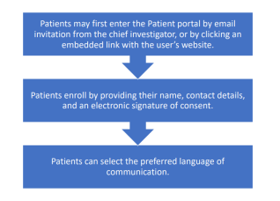

Within the healthcare setting, the following four major steps are applied when using Benchmarc to manage patient outcomes:

**1. Observational protocol:** This is the structured process for gathering information regarding a patient's health status and response to therapy. The observational methodology may change depending on the kind of medical service offered and the disease being treated.

**2. Patient survey:** Patients will be requested to complete a survey to offer details about their symptoms, functional skills, quality of life, or other pertinent aspects of the observational protocol calls for it. To provide a baseline measurement of the patient's outcomes, the survey is often given out before the beginning of treatment.

**3. Results graphing:** Upon completing the patient survey, the patient's results will be graphed or plotted across time. This enables medical professionals to follow a patient's development visually and spot any patterns or changes in their results.

**4. Personal patient portal:** The patient can access the results and any photographs uploaded to the system during the case completion through a Personal Patient Portal. Patients now have access to their medical records, enabling them to monitor their progress and receive the appropriate therapy. Patients may be able to communicate with their medical professionals through the portal and access additional information relevant to their care (ISNS, n.d.).

Patients may be able to share feedback on the Benchmarc platform regarding their experiences with various treatments, including treatment efficacy, side effects, and general satisfaction. A patient receiving two or more treatments and managing numerous cases simultaneously can move between them at the site and finish the surveys using the same login information. The Benchmarc interface allows patients involved in many cases and receiving various therapies to complete questionnaires for each case under a single account (ISNS, n.d.). To provide input on various treatments or cases, the patient would no longer need to create multiple accounts or log in and out of various accounts. This feature enhances the user experience for patients by offering a quick and easy way for them to provide feedback on their medical care.

**4.1.2. InCytes**

The following steps provide a guide on how users can join and use inCytes for the management of clinical data and patient conditions:

***Selecting Circle Role(s)***

The various roles in InCytes seem to have been created to make collaboration and project management for medical research easier, allowing users to contribute in different ways based on their positions and areas of expertise. The roles from which to choose are as follows:

**i. Sponsor**: A user who offers subscriptions or case credits to all other Circle participants is known as a sponsor.

**ii.** A user who has been invited to join a Circle by an administrator is referred to as a **Circle Member.**

**iii. Team Member**: A member of the medical community who helps with certain duties in the day-to-day practice, such as case creation, patient enrolment, or Circle administration. Despite full access to the account, they cannot be designated as Circle administrators.

**iv. The Circle Administrator or Founder** is the person who creates and manages the Circle, including its name, PHI settings, observational protocol, descriptions, and membership**.**

**v. Service Provider**: This is a third-party role for InCytes Circles. A person who works in a setting other than a clinic, such as a laboratory, is assigned to fill this position. The Service Provider can help investigators by finishing blood tests, characterization results, and other tasks on their behalf (ISNS, n.d.).

***Adding/Removing Team Members***

Each user is given the option to invite one or more teammates. They have complete access to your account and can help with tasks like case development, patient enrollment, and circle management.

To invite a new member of the team:

1. Choose "Profile" from the navigation bar's bottom.

2. In the Team Members Field, select Invite.

3. Provide the appropriate email address and, if necessary, choose the invitee's preferred language.

4. Press the invite button.

5. Your team member will shortly get a message encouraging them to sign up and become a part of your group.

**To eliminate a team member**

1. Choose "Profile"

2. Choose the team member's name by clicking the three dots.

3. Choose “Remove” (ISNS, n.d.).

***Registration***

Investigators can join InCytes by accepting an invitation into a circle, in which case they will receive an email with a direct registration link or by joining directly online (RegenMed, 2021). Investigators must enter an email address and an 8-character password to safeguard their account storage. Location of pi or personal information is frequently specific by country, region, or institution; insights currently offers two PI locations in Canada and the United States; choose carefully which one best meets your needs, as once the account is created, it cannot be changed (ISNS, n.d.). Lastly, investigators can choose whether to protect their account with 2FA or two factor authentication; when ready to proceed, please read and sign the consent to the terms and conditions.

**Summarized steps**

1. The invited team or a colleague should have sent you an email or social media invitation link. When you arrive at the login page, click Sign Up. Then, enter the required information for your account.

2. Preferred PI region (country where you will store your personal information (PI) data): First name, last name, email (please use the same email that was entered into the system when the invitation link was sent),

3. Please take the time to read the Terms & Conditions carefully; once done, please check the box to agree and click next. Create a password.

4. When you click NEXT, notifications@incites.com should email you a verification code to complete the account registration process. To sign up, cut and paste this code into the appropriate field.

5. After clicking SUBMIT, you can access your account dashboard (ISNS, n.d.).

***How to Accept an Invitation to a Circle***

For those who are new to InCytes, follow these steps:

1. Open the invitation email and click on the "Register Now" button. This platform connects healthcare professionals globally to safely generate, collect, and analyze real-world data. 2. Complete the sign-up process.

3. Once registered, you will be directed to your dashboard.

4. To access the Circles Overview Page, select "Circles" from the navigation menu on the left-hand side (ISNS, n.d.).

5. On your dashboard, view My Alerts to find your circle information

6. Select Accept, and you should be able to view, access, and use your new circle (ISNS, n.d.).

*Figure 2: Circle Overview*

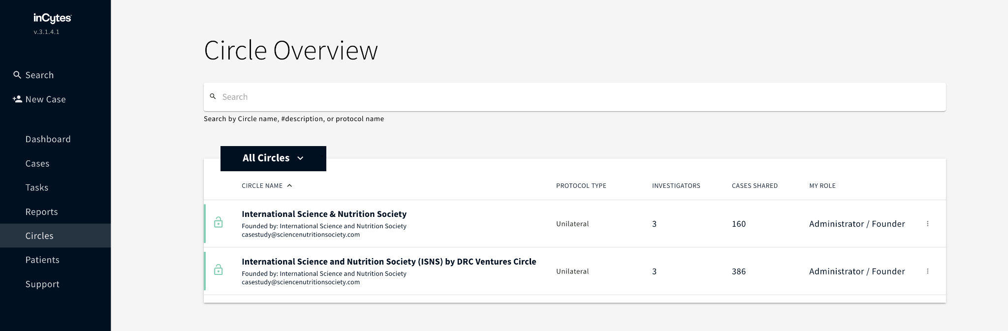

*Figure 3: My Alerts*

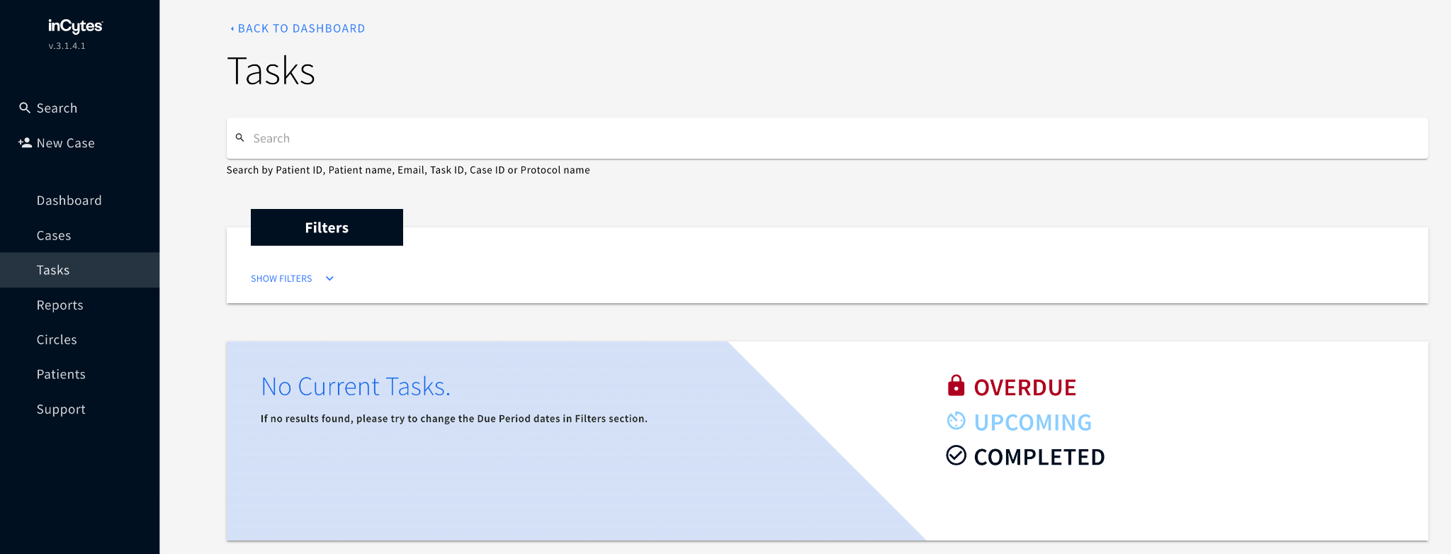

*Figure 4:Alerts Page*

***Health Care Provider Sign Up***

1. In the invitation email, click “Join Now.”

2. You will be redirected to a new page where you will sign up, as shown below (ISNS, n.d.).

*Figure 5: Health Care Provider Sign Up*

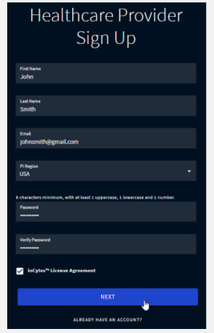

***Healthcare Provider Registration***

Medical billing, claims to process, and other healthcare services are among those that InCytes offers to healthcare providers. A healthcare professional who registers with InCytes receives access to a customized dashboard that lists any duties the company has given them. A healthcare practitioner will be taken to their dashboard after logging into their InCytes account (ISNS, n.d.). They can view any tasks that have been given to them there. These jobs could entail examining and approving medical claims, updating patient data, or submitting billing data. If the dashboard is blank, no tasks are assigned to the healthcare practitioner. Nevertheless, if they are given a task in the future, it will instantly show up on their dashboard. Healthcare professionals may keep on top of their duties and ensure they finish important activities on time by frequently checking their dashboards.

*Figure 6: InCytes Dashboard*

*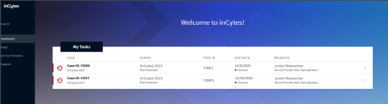****How to Create and Test a Test Case***

Once you have activated your subscription, you can start working on your first case. The case will continue to be worked on up until the conclusion of the final survey in the Observational Protocol. The results of each survey will be accessible at any time and made public as soon as possible once they have been tabulated (ISNS, n.d.).

*Figure 7: Adding a Test Case*

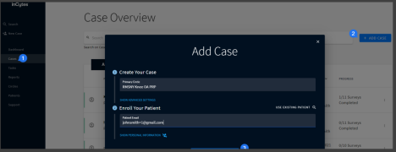

Navigate to Cases in the left navigation bar to get started. At the upper right of the screen, select +ADD CASE. In the Create Your Case field, provide the name of your Circle. You can omit the advanced settings from test cases unless you also want to test them. Enter your test patient's email in the patient email field by choosing from the options below: Use any email address you may have other than the one you use to sign up as an investigator. Start a new email account. Use your email address+1 to register your patient if you have already registered in the system with a @gmail address (ISNS, n.d.). For example, if you registered with johnsmith@gmail.com on the clinician portal, you can use johnsmith+1@gmail.com to register your test patient and access the patient portal with this email. This lifehack works exclusively with Gmail). Click CREATE CASE to finish (ISNS, n.d.).

***How to Delete Test Case***

The steps to remove a test case from InCytes are as follows: Start by picking the "Cases" option in the left navigation bar to go to the "Cases" section. Find and click on the exact test case you wish to remove. Once in the relevant test case, look at the top right of the screen, where you will see the "ARCHIVE CASE" button (ISNS, n.d.). To begin the process of eliminating the test case, click the "ARCHIVE CASE" button. You will be prompted for confirmation before archiving or deleting the case. To finish the procedure, click "CONFIRM." The test case will vanish from the list of cases once you've confirmed the deletion, signifying a successful deletion. Ensure you delete the test case permanently before confirming the action. Once it has been deleted, it cannot be recovered.

*Figure 8: Deleting an InCytes Test Case*



***How to Review Your Protocol***

The capacity to establish and manage research protocols is one of the many services offered by the healthcare platform InCytes to healthcare practitioners. There are various processes involved in reviewing your procedure on InCytes:

1. Register for an InCytes account: You must sign into your InCytes account with your username and password to read your protocol.

2. Go to the "Protocols" section after logging in: The "Protocols" part is typically found in the left-hand menu bar.

3. Find your protocol here: Find the protocol you want to evaluate in the list of protocols shown on the screen.

4. Launching the protocol: To access and see its information, click on its name.

5. Review the protocol: As soon as it is open, carefully review all the information, including the study design, eligibility requirements, study protocols, and data collection techniques.

6. Change the protocol (if required): You can edit it by selecting "Edit Protocol" and making the required modifications if you see any mistakes or believe it needs to be changed.

7. To submit the protocol for review, click the "SUBMIT" option after you have completed any necessary revisions and are pleased with the procedure.

8. Upon submission of the protocol, you must wait for feedback from the InCytes team. Before the protocol may be authorized, you must respond to any comments, recommendations, or requests for more details that they may make.

9. The protocol can be finished using the "Finalize" button after any comments have been addressed and the protocol has been accepted (ISNS, n.d.).

You can ensure that your study is planned and carried out efficiently and ethically by carefully examining your protocol and making any necessary adjustments.

***How to Register a New Patient***

Depending on the services being used, InCytes may also have extra features or criteria for patient registration. Medical professionals can add patients to their InCytes list and ask them to register for Benchmarc. They can view their health information, communicate with medical professionals, and access additional services (ISNS, n.d.). Understanding how a patient can be registered into the inCytes database is important. Below are the steps involved in patient registration on InCytes:

**1. Locate the " Patients " area**: Choose "Patients" in the navigation bar on the left-hand side of the screen from the InCytes dashboard.

**2. Add a new patient**: To add a new patient, select the “+ADD PATIENT” button in the top right corner of the screen.

**3. Enter the patient's details**: Enter the necessary patient data, including the patient's email address, birth date, and cell phone number, in the box that appears. As required, you can also enter more patient data.

**4. Submit the data**: After entering all the necessary patient data, click the "SUBMIT" button to save and send the patient's information (ISNS, n.d.).

*Figure 9: Registering a new client. 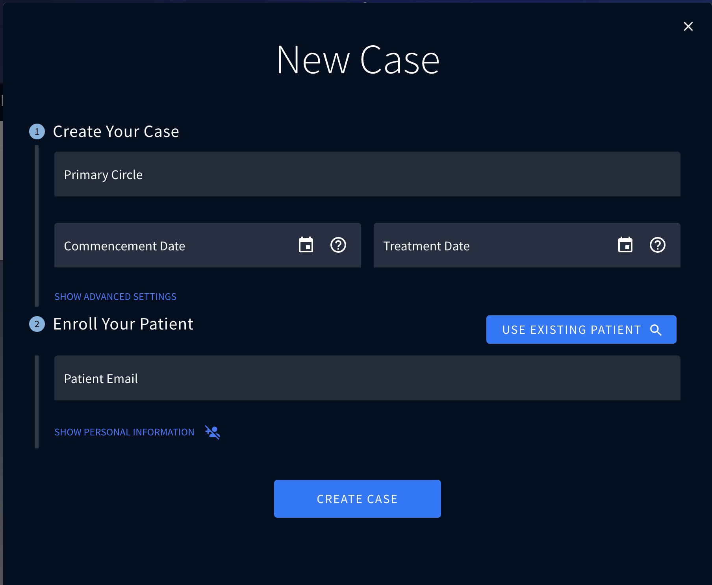*

**5. Sending an invitation to patients**: The patient will receive an email invitation to register for Benchmarc, the Personal Patient Portal, as soon as you submit their information. The patient will use this gateway to access their medical records, connect with their doctors, and utilize other InCytes services (ISNS, n.d.).

*Figure 10: Registration Completed*

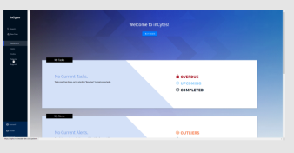

It is crucial to remember that patients can finish the registration process whenever they attempt to access Benchmarc if they are interrupted while it is being done. Patients occasionally fail to finish the enrolling procedure, leaving their status as "Pending" (ISNS, n.d.). In certain circumstances, healthcare professionals can resend the invitation to the patient to nudge them toward finishing their enrollment. The processes to resend an invitation are as follows:

1. From the navigation menu on the left-hand side of the screen, choose "Patients." You will then be sent to your patient list.

2. Find the patient to whom you want to resend the invitation. If someone's enrollment status is "Pending," that suggests they haven't finished it yet.

3. To access the settings menu, click the three dots next to the patient's name. 4. Choose "Resend Invitation" from the options menu. The patient's invitation email will be sent again to the email address linked to their account. The patient can finish the signup process and start using Benchmarc as soon as they receive the invitation email (ISNS, n.d.). Healthcare professionals can maintain track of which patients have enrolled and which are still waiting by monitoring the patient list. They can then resend invites as necessary to ensure all patients have access to the services offered by InCytes.

***Creating a New Case***

An incident of a patient undergoing a specified observational protocol is referred to as a case in InCytes (ISNS, n.d.). A case is generated when a medical professional designates a patient to a certain observational procedure, sponsor, or Circle. When a case is generated, the following takes place:

i. An observational protocol is a collection of instructions healthcare professionals use to gather information about a specific patient population. A patient who is enrolled in an observational protocol will be required to respond to questionnaires and provide information that will be used to assess their health condition and treatment outcomes.

ii. Pharmacies and other businesses interested in learning more about a certain patient population are often sponsors. They might contribute money or other materials to help the observational protocol.

iii. A circle is made up of healthcare professionals who collaborate to gather information about a certain patient population. They might work together to create the observational protocol, find patients, and gather information (ISNS, n.d.).

A case is made when a patient is assigned to an observational protocol, a sponsor, and Circle. The case will continue up until the conclusion of the final survey in the observational protocol. The prescriber of the observational protocol will have quick access to the patient's

survey responses and other data when provided. The healthcare provider can use this information to track the patient's development, assess the effectiveness of the treatment, and make any required modifications to the patient's care plan (ISNS, n.d.). InCytes cases enable healthcare professionals to gather and evaluate data orderly and systematic, making it simpler to track patient progress, spot trends, and enhance patient outcomes. Below is a summary of the steps involved in creating a new case:

1. On the Case Overview Screen or New Case in the left navigation bar, click ADD CASE. 2. Enter the sponsoring (Primary) Circle, where the observational protocol automatically applies.

*Figure 11: Creating a new case*

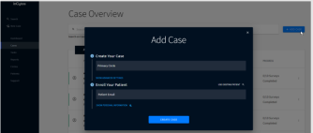

3. Employ "Advanced Case " settings to modify the case to your needs. Advanced Case Settings are extra customization choices that healthcare professionals can use to mold a case to their requirements. Following are some instances where medical professionals might make use of advanced case settings:

i. Occasionally, healthcare providers may alter the survey questions in an observational program to suit their patient demographic better or to gather more precise data. They can add, remove, or edit survey questions as necessary using the Advanced Case settings.

ii. The timing of surveys may need to be changed to collect data at more precise intervals, depending on the patient population and the objectives of the observational study. They can alter the scheduling of surveys using Advanced Case options to meet their needs best.

iii. Adding research-specific details: In some circumstances, healthcare professionals may want to include further details regarding the observational procedure or study to better inform patients about its objectives. They can add unique text or other information to the case using advanced case settings.

iv. Healthcare professionals can tailor cases to better meet their needs and the needs of their patients by using Advanced Case settings. They may be able to gather more pertinent and reliable data in this way, monitor patient progress more successfully, and produce better results (ISNS, n.d.).

4. Enter the patient's email address if they are new, or choose an existing patient*.* Normally, when registering, patients will enter their personal information; however, if you would like to do so here, please select Show Personal Information. You can then enter the patient's first name, middle name, last name, country, mobile phone, birthdate, and PI region, where you prefer to store the patient's information (ISNS, n.d.). Healthcare practitioners can add existing patients to their dashboard in InCytes or register new patients. Healthcare professionals must enter the patient's email address to add a new patient. After entering their email address, the patient will receive an email invitation to register for Benchmarc, the Personal Patient Portal. The healthcare professional may choose the patient from their list if they are registered. After being chosen, the healthcare professional can see and, if necessary, edit the patient's information. The healthcare practitioner can choose "Display Personal Information" to include further details such as the patient's first name, middle name, last name, country, cell phone, birthdate, and PI region if the patient is brand-new and hasn't yet filled out their personal information during registration. The area where the healthcare provider wants to keep the patient's information is called the PI region.

Healthcare professionals who work in many locations and must maintain patient information arranged by region may find this helpful. The patient will receive an email invitation to sign up for Benchmarc once the healthcare professional has completed filling out all the required fields (ISNS, n.d.). Ultimately, the InCytes patient registration process enables medical professionals to track their patients and monitor their development via observational protocols. Healthcare professionals may ensure they have correct and current information about their patients by adding and editing patient information, which can help them deliver better treatment and achieve better results.

5. *Click CREATE CASE when done*. The final step is clicking “CREATE CASE,” as shown in the image below.

*Figure 12: Create Case (ISNS, n.d.)*.

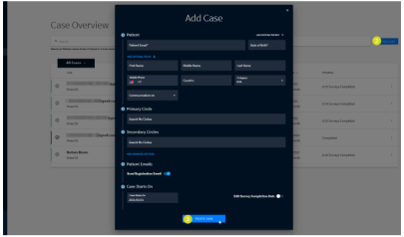***Data Entry***

**i. Delegates**

Surveys can be given to delegates in InCytes, who will then be given a job and deadline for finishing the survey. When designing the observational protocol for a circle, survey delegates are defined and given roles in fulfilling a specific survey. On their dashboard, survey assigners can view their assigned surveys, along with their delegates and statuses (ISNS, n.d.). The task assigner can finish a task themself, reassign or close a task, or send a reminder to a delegate. Patients, team members, other professionals, or service providers may be given surveys. Service providers can be designated independent assignees and alternatives to help with survey completion. The following are the results of the survey.

The ability to assign delegates makes it easier to enter data and complete surveys with more freedom. It allows healthcare professionals to assign assignments to particular team members, other clinicians, or service providers, which expedites survey completion and saves time. By designating delegates, the survey assigner may make sure the right individual fills out the survey and, if necessary, follow up with reminders or take action to finish the assignment themselves (ISNS, n.d.). This function generally ensures that all pertinent information is appropriately input and stored in InCytes. The system will remind the survey delegate about their task on the due date.

*Figure 13: Due date notification for delegates*

*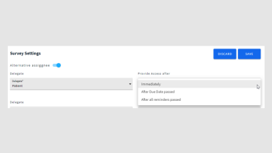***ii. Clinicians/Service Providers**

Clinicians and service providers who haven't enrolled yet will get an email with an invitation link. Before they can access their duties, they must first register. Tasks can be found by individuals who have already registered on their dashboard or the task’s summary page (ISNS, n.d.). The tasks are also visible to service providers designated as alternate assignees.

**iii. Patients**

Patients who have not yet registered will get an email invitation. After completing a short registration process, they will be directed to the first survey once they click the invitation (ISNS, n.d.). Patients already signed up for Benchmarc can find all survey alerts on their dashboard.

***Report Building***

Building a report begins with the creation of a template. The steps for making a new template in inCytes are as follows:

1. On the inCytes homepage, click the Report tab in the left pane. Then, select the "+BUILD REPORT" link in the page's upper right corner. This action will generate a new report.

2. In the field provided, give the template a name. Click "CREATE REPORT" once you've entered the name. The Report Builder will launch as soon as that happens, letting you begin making your template (ISNS, n.d.).

*Figure 14: Reports Overview*

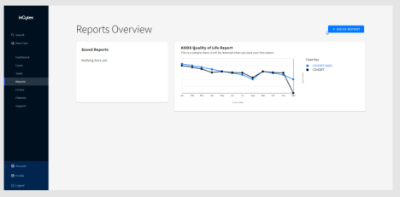

Using these steps, you can quickly create a new template in inCytes, allowing you to save and reuse a specific format or layout for subsequent reports. Using this method, you can quickly create templates tailored to your needs and conserve time when producing new reports. "Templates" are pre-designed report structures that can be modified to produce individual reports with the desired data and layout when handling inCytes reports. On the "Reports Overview Page," under the "Saved Reports" section, you can access and manage these templates (ISNS, n.d.). After a template has been made, it can be changed by removing, renaming, or changing the report's format and content. This gives users the ability to create reports that best suit their needs. Users can click on the "Refresh" icon in the upper right of the Report Builder to update the data in a report. The most recent statistics will be used to update the data in the report.

*Figure 15: Report Builder*

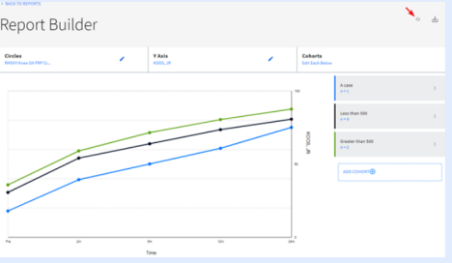

The built reports may also be edited occasionally as deemed fit. The user should choose the desired template from the "Report Overview Page" before clicking the "EDIT" button to start the procedure. By doing so, the "Report Builder" will open, allowing the user to edit the report as necessary (ISNS, n.d.). Selecting the data points for the report is the first step in changing the template. To do this, choose the pertinent data points by clicking on the circle next to each one. The user must then determine the Y-Axis of the report. The graph or chart's vertical axis, known as the Y-Axis, shows the values of the chosen data points. The user can select the proper Y-Axis by selecting the pertinent option from the list of options. The user must next select the necessary cohorts for the report. Users are grouped into cohorts based on shared traits or characteristics to segment the data for analysis. The user can choose suitable cohorts based on their requirements and the report's goals. After completing these three steps, the user can save the modifications made to the report template and generate the revised report with the new data and settings.

***Renaming and Removing Reports***

The user must find the report they wish to remove on the Report Overview Page to remove it. They can then click on the three dots that show when they move their mouse cursor over the report. The user should choose "Delete" from the list of options appearing after doing this (ISNS, n.d.). When asked to confirm the action, they can choose "REMOVE" to delete the template or "CANCEL" to stop the procedure by pressing the appropriate button.

*Figure 16: Removing/renaming a report 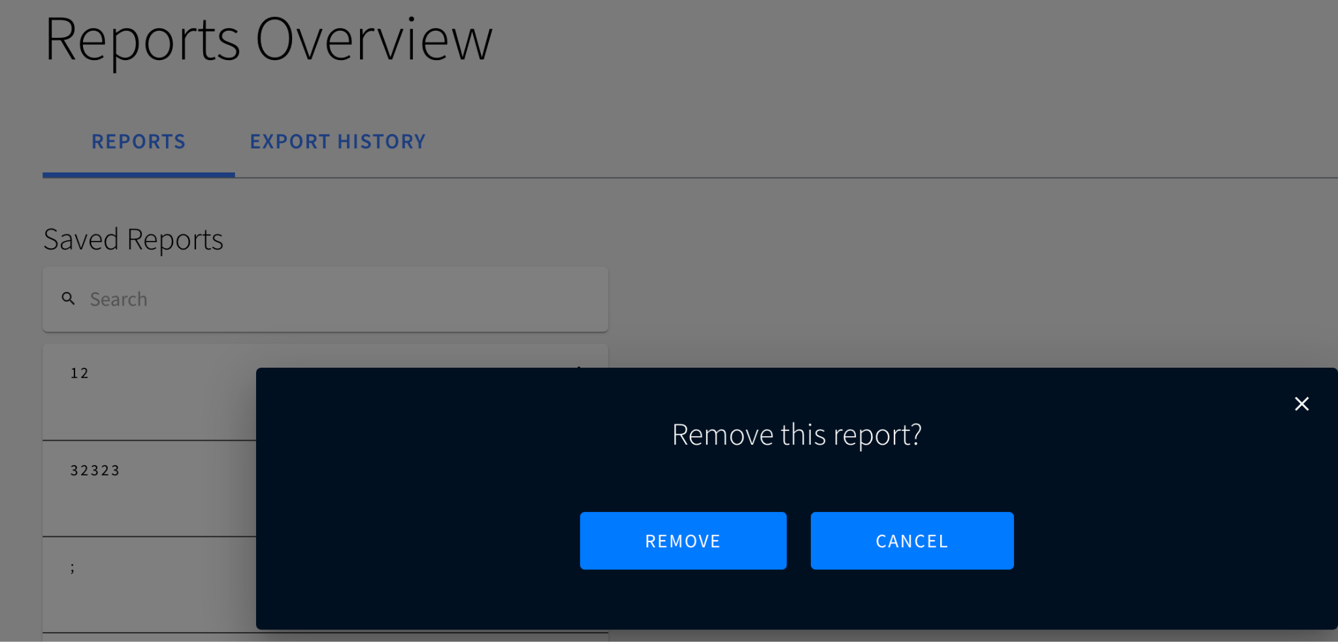*

***Locating a Circle to Build Data***

The user must change the name of the circle the report is based on to rename it. They can do this by selecting the pen icon in the Report Builder's "Circles" section. Then, they can click "UPDATE REPORT" after entering the name of the necessary circle or choosing it from the list of suggested names (ISNS, n.d.). The report's name will change as a result. Users may manage and edit their reports in the inCytes platform by following these steps, renaming or eliminating them as necessary to keep their data current and organized.

63

*Figure 17: Locating a Circle*

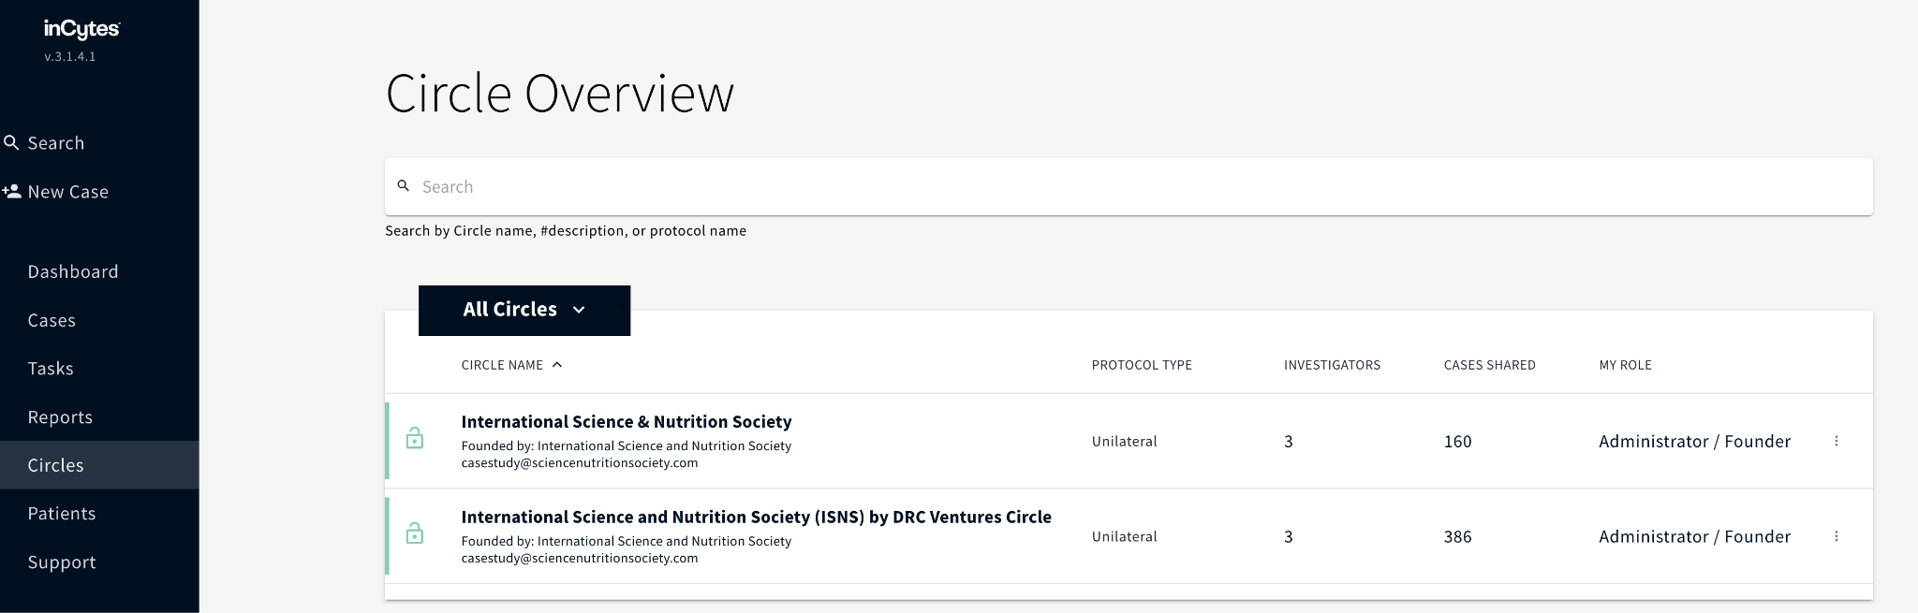

***Cohort Building***

Two default cohort filters are shown on the right side of the Report Builder when a user adds a Y-axis to their report. Only the information about the user's patients is shown in the first cohort filter, "Cohort A," which is labeled and underlined with a blue line on the left. This indicates that the report will only display information about the patients added to the user's circle (ISNS, n.d.). The second cohort filter, "Cohort B," shows information for all cases made inside the user's circle, including information on the patients of all circle members. In other words, the report will include information on the user's patients and those in their circle.

The user can alter the cohorts in their report by choosing various parameters for each cohort filter. For instance, they could develop a cohort that only provides data for patients of a certain age or gender or who have undergone a particular diagnosis or course of therapy (ISNS, n.d.). Users can segment their data and get more granular insights into their patient's health outcomes and treatment efficacy by creating unique cohorts. Users can easily customize cohorts on the inCytes platform to help them produce reports that best suit their needs.

*Figure 18: Building cohorts*

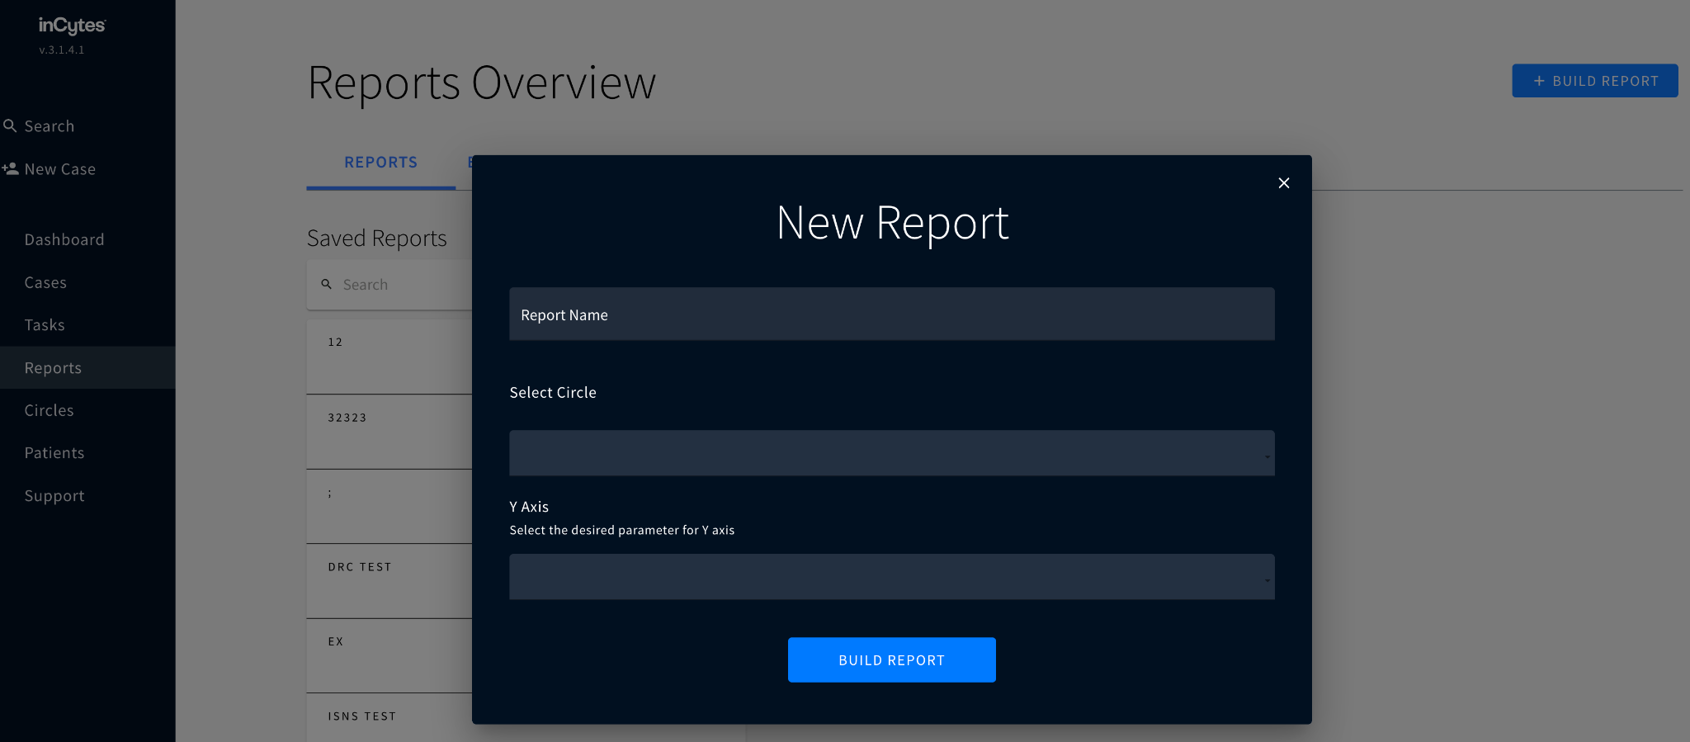

***Adding a Cohort***

The steps for adding a cohort to the inCytes platform are listed below.

1. To add a cohort, the user should click the "ADD COHORT +" button in the Report Builder. They can then personalize the new cohort filter that suits their needs.

2. The relevant cohort attribute can then be entered into the filter or chosen from a list of suggestions by the user. This could include information on a person's age, gender, diagnosis, or medical history. Users can then configure the filter only to contain information that satisfies the defined criteria.

3. The filter can be added to the report by clicking "ADD COHORT FILTER" after the user has set it. Before proceeding to the next stage, users might add all the filters they desire to use simultaneously.

4. Once all relevant cohort criteria have been added to the report, the user should click "DONE" at the bottom. By doing so, the report will be updated to reflect the new cohort (ISNS, n.d.).

*Figure 19: Adding a cohort*

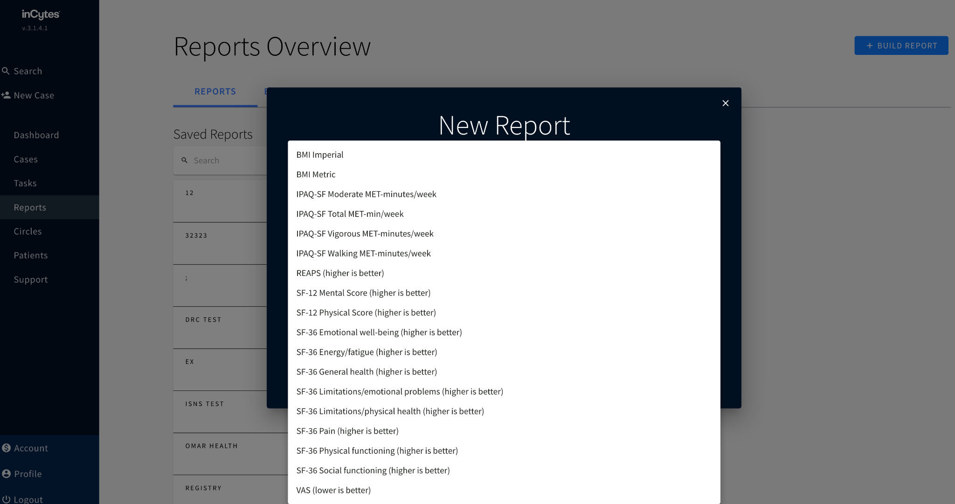

These methods make it simple for users to add cohorts to their reports, segment their data, and get more detailed information about their patient's health outcomes and treatment efficacy (ISNS, n.d.). The inCytes platform is an effective tool for managing and analyzing healthcare since it simplifies cohort construction and customization.

***Removing a Cohort***

The user must first find the cohort they want to delete in the Report Builder before they can remove it from a report. They can choose "Delete" from the menu by clicking the three dots next to the cohort. The user will be asked to confirm the deletion after choosing "Delete" by choosing "REMOVE" to delete the cohort or "CANCEL" to stop the operation (ISNS, n.d.). The cohort will be permanently removed from the report if the user chooses "REMOVE." The report will no longer contain any information related to a deleted cohort; it is vital to remember this. Hence, users should ensure they have exported any necessary data before removing a cohort. Users should use caution while deleting cohorts from their reports since, once deleted, they cannot be recovered.

*Figure 20: Removing a cohort 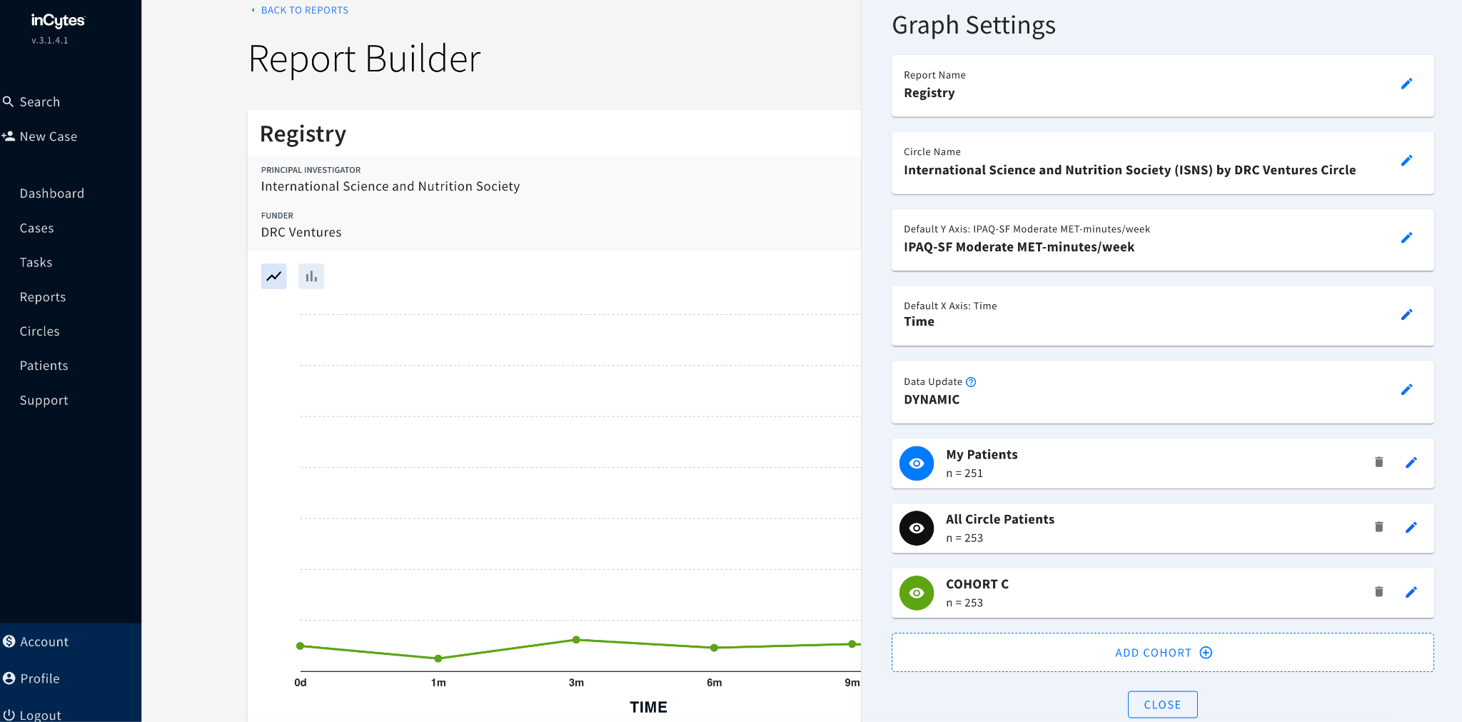*

***Editing a Cohort***

The steps for editing a cohort on the inCytes platform are listed below.

1. To edit it, the user must click on the three dots adjacent to the cohort they want to alter. They should choose "Edit" from the list of available alternatives.

2. They should then pick "Edit" and click the "EDIT" button at the top of the modal window that displays.

3. They should click the filter option they want to alter on the modal window's left side. This will display the cohort-specific filter choices.

4. The user can then modify the filter options as needed, such as choosing a different diagnosis or course of therapy. When finished, they should press "UPDATE" to save their modifications. Alternatively, they can select "DELETE" to eliminate a filter choice from the cohort.

5. The user should click "DONE" to save their changes and close the modal window once they have completed modifying the cohort (ISNS, n.d.).

Users can quickly edit their cohorts in the inCytes platform to provide more precise and pertinent reports. Platform users can also segment their data and obtain insights into patient outcomes and treatment efficacy using the platform's simple-to-use tools for tailoring cohorts.

*Figure 21: Editing a cohort*

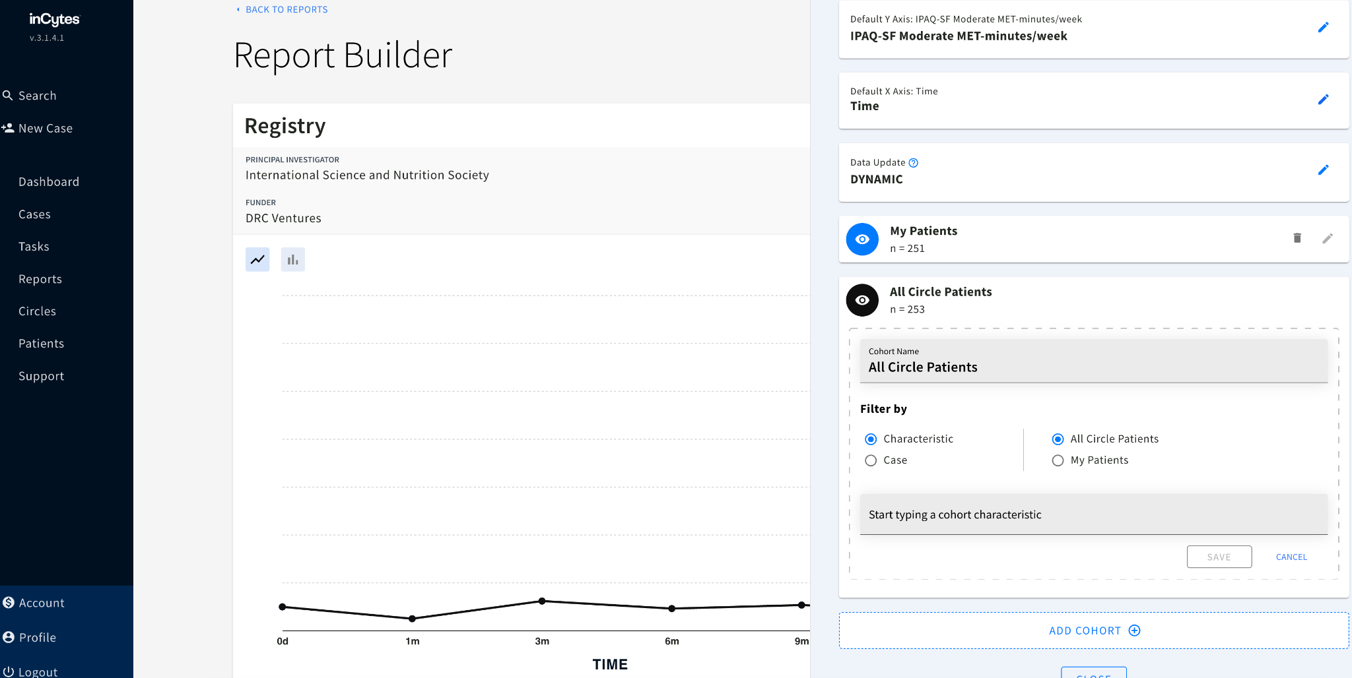

***Renaming a Cohort***

The procedures for renaming a cohort on the inCytes platform are listed below.

1. The user must select "Edit" from the menu when they click on the three dots adjacent to the cohort they wish to rename. A modal window containing the cohort settings will be opened.

2. The user should select "SETTINGS" at the window's top once the modal window has opened.

3. The user must then type the cohort's new name in the relevant field and click "UPDATE" to save the changes.

4. The user can choose between "all circle patients" and "just your patients" while in this modal window to specify what information they want the cohort to provide. By doing so, the user can further tailor the cohort settings to suit their requirements.

5. After updating the cohort’s name and preferences, the user should click "DONE" to exit the modal window and save the changes (ISNS, n.d.).

These methods make it simple for users to rename cohorts in the inCytes platform and modify how their data is displayed to suit their analytic needs. Users can create more informative and useful reports using the platform's user-friendly interface for maintaining and customizing cohorts.

*Figure 22: Renaming a cohort*

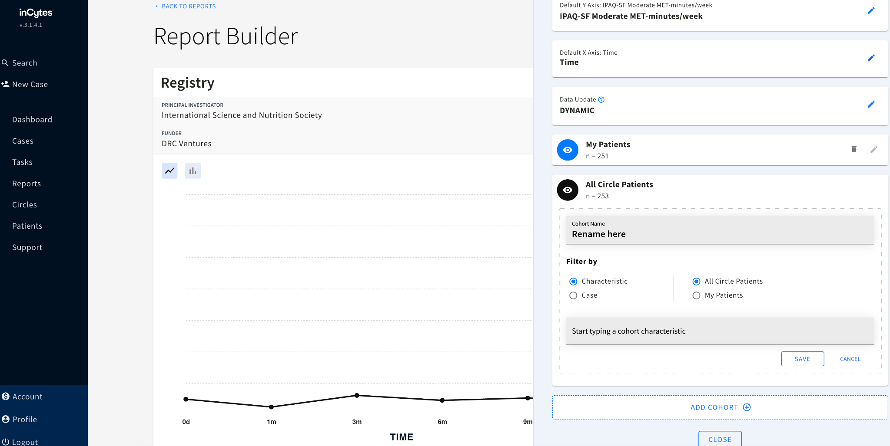

***Reading Legend***

InCytes has a function called report builder that enables customers to design unique reports and see performance metrics for their company. Data for each cohort included in the report are shown using the statistic legend tool in the report builder (ISNS, n.d.). Cohorts are often collections of users or clients who exhibit similar traits or habits, and they are frequently used to assess performance across various market segments.

Each cohort is shown in its column in the statistical legend, with the first column bearing the labels "Cohort A," "Cohort B," and so on, up to "Cohort D" (ISNS, n.d.). Depending on how many cohorts are included in the report, a different quantity of data will be included in the legend. Users must pick the appropriate report from the Reports tab, then click the "EDIT" button in the report builder's upper right corner to access the statistical legend. The performance information for each cohort in the report should be displayed in the legend, which should appear below the report builder.

***How to Export a Report***

Users can save and download a copy of their report for offline viewing or sharing by exporting a report. The processes to export a report are as follows:

1**. Go to Reports:** The first action is to find the report by navigating to the analytics platform's Reports area.

2. **Decide which report you prefer:** Select the report you want to export from the list of Saved Reports. If one hasn't already been created, click the "+ BUILD REPORT" button to generate a new report.

3. After choosing the desired report, click "EDIT" in the top right corner of the screen to access the report builder.

4. To verify that your report contains the most recent data, click the Refresh symbol in the top right corner of the screen. By doing this, the report's data will be updated with the most recent information the system offers.

5. After the report has been updated, select "Download Report" by clicking on the button in the top right corner of the screen. The platform will then be prompted to produce the report and download a link.

6**. Launch the file:** Finally, use a tool that supports the.xlsx file type, such as Microsoft Excel, to open the downloaded report on your device. The data and formatting of the report should be present when it opens, enabling you to inspect, examine, or distribute it as necessary (ISNS, n.d.).

***How to Read the Exported Report***

The data in the downloaded Excel file should next be reviewed and analyzed after exporting a report from the analytics platform. The following advice will help you understand the exported report:

1. Change the ownership level of the data: The report may contain personally identifiable information (PI), which not all users can see. Circle Admin and Circle members can change the data ownership level to make PI data visible or invisible in the generated Excel report.

2. After the report has been altered to reflect data ownership, open the Excel file and select the Cohort tab for more details (or tabs if there are multiple cohorts). This tab will thoroughly analyze the data for each instance chosen from the cohort, including details on consumer demographics, purchasing patterns, and other pertinent variables.

3. Go to the Legend tab to better understand the data in the Cohort tab (usually the first tab in the Excel file). The report's many metrics, data points, pertinent units, and other crucial details are explained on this tab.

4. Extra tabs: The Excel file may have additional tabs with additional data or metrics, depending on the intricacy of the report. These tabs could provide summaries of the data, comparative analysis, graphs, charts, or other visual representations of the data (ISNS, n.d.). Businesses can enhance their operations by examining and evaluating the exported report to acquire valuable insights into their performance, consumer behavior, and other important indicators.

***Circle Administrators***

In the context of the analytics platform, those with complete access to the information gathered by each Circle member within a particular Circle are referred to as Circle Administrators. The following are important considerations for Circle Administrators:

1. Whole Circle data access: Within a given Circle, Circle Administrators have access to and can examine all of the data gathered by Circle members. This comprises details about customer demographics, purchasing patterns, and other pertinent variables.

2. Customized questions and PROMs: Based on each Circle member's particular needs and requirements, Circle administrators can tailor the questions and PROMs (Patient Reported Outcome Measures) for that Circle member.

3. A whole list of questions and PROMs: When Circle Administrators obtain a report, they will also get the complete list of questions and PROMs used to collect data for the Circle. They could learn more about the data and how to use it to inform business decisions as a result of doing this.

4. Raw data export: Circle Administrators can get the Circle's complete raw data export in addition to the report from the Circle Details Page. With no cohort distinctions, this export encompasses all Circle data and enables more in-depth analysis and specialized reporting (ISNS, n.d.). In general, Circle Administrators play a significant part in maintaining and analyzing Circle data, utilizing their access and knowledge to gather insightful information and influence business choices.

***Downloading Full Raw Report***

Users of the analytics platform can get the entire raw report for a particular Circle. The steps are as follows:

1. Go to Circles: The first step is to select the desired Circle from the list of Circles on the analytics platform's Circles tab. By doing so, the Circle Overview Screen will appear, giving you a broad overview of the data gathered within the Circle.

2. Now find the FULL RAW EXPORT button in the top right corner of the Circle Overview Screen and click it. This button's click will start the complete raw report's download procedure.

3. Download the file: After downloading, you must use an application that supports the.xlsx file format to open the file on your device. As a result, you can access and examine the raw data in a spreadsheet format, giving you a more in-depth and precise understanding of the Circle's data (ISNS, n.d.).

In general, businesses wishing to obtain deeper insights into their performance, consumer behavior, and other important indicators may find it useful to download the entire raw report (ISNS, n.d.). By examining the data in a spreadsheet, businesses might find novel trends and patterns in the raw data that might not be immediately obvious in a regular report.

**4.2. Themes from Literature**

The review of the literature and the overview of the Circles system, which uses the InCytes and Benchmarc platforms, led to the development of major themes surrounding global health registries. These include “the current landscape of healthcare technology,” “the use of RWD and RWE in assessing the efficacy of medications,” “the use of registries in enhancing care coordination and patient outcomes,” and “issues of data safety regarding registries.” The review also showed the primary features of the inCytes’ Circles program and explained how it could benefit healthcare providers. Below is an explanation of these findings.

**The Current Landscape of Healthcare Technology**

The world is becoming more digital, which is a shift affecting virtually every facet of existence. Because of this rapid adoption, there is now an unprecedented amount of data regarding health care. This data has been generated from various real-world sources, including electronic health records (EHRs), medical claims and billing data, prescription data, digital health apps, observational studies, disease and product registries, and surveys (Fendrick, 2021). Data is being generated due to an increasing amount of information collected from people's wrists via wearables or transmitted to us from houses employing monitoring devices (Dinh-Le et al., 2019). This data, which is also known as "real-world data" (RWD), is described as health related information that is reported and gathered in real-world medical settings rather than in the context of standard randomized controlled trials (RCTs) (Fendrick, 2021). Together with the results of randomized controlled trials (RCTs), these and other patient-reported outcomes research data could be a helpful addition to the gold standard of RCTs, assisting clinicians and their patients in more personalized patient care, possibly leading to improved outcomes. Wearable technologies and in-home monitoring devices can individually track a person's fitness, nutrition, and other health parameters. In the meantime, electronic health records (EHRs) have become the norm at the practitioner level: in 2017, approximately 86 percent of office based physicians in the United States used an EHR system, compared to only 42 percent in 2008 (Fendrick, 2021). The rapid adoption of digital technology during the COVID-19 pandemic has also made it possible for healthcare providers and researchers to take advantage of novel approaches to patient engagement. These approaches, which range from telehealth to clinical trials, enable patients to participate in research from a distance through wearable devices, patient questionnaires, and connected sensors (Fendrick, 2021). The significance of RWD has been acknowledged for some time by regulatory agencies such as the Food and Drug Administration (FDA) in the United States.

Although randomized controlled trials (RCTs) are currently the gold standard for evaluating regulatory applications for drugs and devices, fit-for-purpose RWD is also regarded as a possible tool to inform some submissions. RWD and the evidence derived from such data, referred to as "real-world evidence" or RWE, have several benefits and drawbacks (Fendrick, 2021). It is possible to highlight how individuals use accessible health care, such as services, equipment, and prescriptions, by getting information across varied patient groups that may not be properly recorded in clinical trials. This information can be obtained through electronic health records (EHRs).

So, RWD/RWE studies, which can only evaluate correlation and not causation, should be seen as an addition (but not a replacement) to the data available through RCTs. This is because these analyses are the only ones that can evaluate correlation (Fendrick, 2021). They supplement clinical trials by allowing for a wider variety of treatment scenarios and possible comparisons from the real-world setting than is typically available in literature solely based on RCT data. This makes it possible to draw more meaningful conclusions about the efficacy of various treatments (Fendrick, 2021). Specifically, RWD can provide additional information regarding the overall patient experience or journey. This is particularly important as the healthcare industry addresses health equity issues, including inequities in disease prevention, assessment, intervention, and care. The following is a summary of the difficulties and restrictions associated with RWD/RWE:

1. Because RWD/RWE analyses can only analyze associations and not causality, so they answer different problems than RCTs.

2. It is important to thoroughly investigate any concerns regarding potential biases in the data-gathering process due to a lack of randomization and any quality concerns regarding the data-collection process.

3. The data source may hinder the findings' generalizability, endpoints, and the data type used.

4. Data from the source is either missing or wrongly coded (Fendrick, 2021). **The Use of RWD and RWE in Assessing the Efficacy of Medications**

The Circles platform considers real-world data (RWD) and real-world evidence (RWE) to determine whether or not a drug is effective. RWD is an abbreviation for "research with data," which refers to data obtained outside clinical trials. Examples of RWD include claims data, electronic health records (EHRs), and patient-generated data (Fendrick, 2021). Observational studies, comparative effectiveness research, and pragmatic clinical trials are all examples of what might be included in RWE, which is developed from the analysis of RWD.

Circles can provide a more in-depth comprehension of the efficacy of a medicine when applied to real-world conditions because it uses both RWD and RWE. This makes it possible to conduct more accurate assessments of the medicine's effect on the outcomes of the patient's condition and can help inform clinical decision-making (Fendrick, 2021). Circles, for instance, can perform RWD analyses to uncover patient factors such as age, gender, and comorbidities that can potentially influence a medicine's effectiveness (Franklin et al., 2020). After gathering this information, one may build specialized treatment regimens tailored to certain patient demographics to achieve the best possible results. In general, incorporating RWD and RWE into determining the efficacy of a medicine can enhance patient care and produce more favorable clinical results.

**The Use of Registries in Enhancing Care Coordination and Patient Outcomes**

When it comes to improving care coordination and the final results for patients, registries are extremely useful tools (Franklin et al., 2020). They offer a centralized site for collecting, storing, and maintaining patient data, which enables healthcare providers to track the development of their patients, identify areas that need improvement, and conduct focused interventions (Council on Children with Disabilities and Medical Home Implementation Project Advisory Committee et al., 2014). The Circles is a registry system developed by inCytes and Benchmarc data tools. Its primary goal is to improve care coordination and patient outcomes (ISNS, n.d.).

Many areas of the healthcare industry use registries, including general care, specialist care, and public health (Laugesen et al., 2021). They can be utilized to evaluate the efficacy of a certain medication or intervention and keep track of individuals who have a particular ailment, such as diabetes (Booth et al., 2019). In addition, registries can be used to monitor the performance of healthcare providers, discover variances in care, and locate gaps in treatment delivery. The Circles registry system was developed to interact with existing electronic health record (EHR) systems (McCoy et al., 2019). Its integration allows medical professionals to collect and maintain patient data in a more time-effective manner.

Using registries like Circles helps improve care coordination, which is one of the primary benefits associated with its use (Kandel et al., 2022). Coordination of care is necessary to provide care that is of high quality and is focused on the patient. It entails good communication and collaboration amongst healthcare providers working in various locations, such as hospitals, primary care practices, and specialty clinics, among other possible examples. The provision of a central site for collecting and exchanging patient information is one of how registries might facilitate care coordination. This allows medical professionals to obtain up-to-date information on a patient's health state, treatment history, and prescription use, which can contribute to improved clinical decision-making and patient outcomes (Haleem et al., 2019).

The ability of registries to facilitate targeted therapies is another way to improve patient outcomes. Registries can identify areas for improvement and tailor interventions to address specific gaps in treatment when they gather data on patient populations. This allows registries to collect data. For instance, the Circles registry system can be used to identify patients with illnesses that carry a high risk, such as heart failure, and then deliver therapies specifically geared toward improving their health outcomes. Medication management, changes in lifestyle, and services to coordinate treatment are some examples of interventions that might fall under this category. Registries have the potential to enhance patient outcomes while simultaneously lowering overall healthcare costs if they provide appropriately focused interventions. The ability of registries like Circles to assist medical professionals in monitoring the efficacy of treatments and interventions is an additional advantage of using such registries. Registries can provide light on the question of which treatments are the most successful for various patient populations since they gather information on the outcomes of patients throughout time. This information has the potential to improve the quality of care provided to patients and the clinical decision-making process.

Monitoring the performance of healthcare providers and discovering variances in how care is provided are two other uses for registries. Registries can assist in identifying variances in care delivery and provide valuable input for quality improvement efforts since they collect data on the performance of healthcare providers (Evans, 2011; McNeil, 2010). The Circles registry system, for instance, can be used to track healthcare providers' adherence to clinical recommendations and best practices, like the proper administration of drugs and screening exams. Registries can assist in raising the standard of patient care and lower expenses by identifying places where medical professionals may not be following protocols or providing consistent care (Franklin et al., 2020)

Moreover, registries like The Circles can aid in advancing community health management programs. Registries can assist healthcare professionals in identifying high-risk patients and implementing focused interventions to enhance their health outcomes by gathering data on patient groups. Preventive care services, illness management plans, and care coordination services can all fall under this category. Healthcare practitioners can lower the prevalence of chronic illnesses, enhance patient outcomes, and cut costs by implementing these approaches. The Circles registry system can also assist in advancing research activities, in summing up. Registries, which gather and examine patient data, can shed light on the efficacy of therapies, point out areas that require more study, and assist in creating novel therapeutic strategies. This can help expand scientific understanding in healthcare and enhance the general quality of patient care.

In conclusion, registries like The Circles can be effective instruments for improving patient outcomes and care coordination. Registries enable healthcare professionals to find areas for improvement, execute focused interventions, and track the efficacy of therapies over time by offering a central site for collecting and organizing patient data. This can save healthcare expenses, increase scientific understanding in the healthcare field, and improve the standard of treatment given to patients.

**Issues of Data Safety Regarding Registries**

Registries are databases that gather and keep information about a certain illness or condition, medical equipment, or drug. They are frequently used to assess safety and efficacy, follow patient outcomes, and guide clinical judgment (Shahnaz et al., 2019). While registries have the potential to advance healthcare by offering insightful information about actual results, they also present significant data security concerns.

The possibility of data breaches is one of the main issues with registries. Registries commonly include patients' names, addresses, and medical histories, as well as other sensitive and individually identifying information (Shahnaz et al., 2019). If these details get into the wrong hands, they might be used for identity theft or other nefarious activities. Furthermore, irresponsible use or improper sharing of registration data might result in moral and legal problems.